**Exercise 1: Inventory Management System (Mandatory)**

**Code:**

import java.util.ArrayList;

import java.util.Iterator;

import java.util.List;

import java.util.Scanner;

public class Inventory {

static class Product {

private int productId;

private String productName;

private int quantity;

private double price;

public Product(int productId, String productName, int quantity, double price) {

this.productId = productId;

this.productName = productName;

this.quantity = quantity;

this.price = price;

}

public int getProductId() { return productId; }

public String getProductName() { return productName; }

public int getQuantity() { return quantity; }

public double getPrice() { return price; }

public void setProductName(String productName) { this.productName = productName; }

public void setQuantity(int quantity) { this.quantity = quantity; }

public void setPrice(double price) { this.price = price; }

@Override

public String toString() {

return "Product [productId=" + productId + ", productName=" + productName +

", quantity=" + quantity + ", price=" + price + "]";

}

}

private final List<Product> products = new ArrayList<>();

public void addProduct(Product product) {

products.add(product);

}

public void updateProduct(int productId, String productName, int quantity, double price) {

for (Product p : products) {

if (p.getProductId() == productId) {

p.setProductName(productName);

p.setQuantity(quantity);

p.setPrice(price);

System.out.println("Product with ID " + productId + " updated");

return;

}

}

System.out.println("Invalid Product ID " + productId);

}

public boolean deleteProduct(int productId) {

Iterator<Product> it = products.iterator();

while (it.hasNext()) {

if (it.next().getProductId() == productId) {

it.remove();

System.out.println("Product with ID " + productId + " removed");

return true;

}

}

System.out.println("Invalid Product ID " + productId);

return false;

}

public void displayProducts() {

if (products.isEmpty()) {

System.out.println("(Inventory is empty)");

return;

}

for (Product p : products) System.out.println(p);

}

public static void main(String[] args) {

Scanner sc = new Scanner(System.in);

Inventory inventory = new Inventory();

int choice;

do {

System.out.println("\n---- Inventory Menu ----");

System.out.println("1. Add Product");

System.out.println("2. Update Product");

System.out.println("3. Delete Product");

System.out.println("4. Display Products");

System.out.println("5. Exit");

System.out.print("Enter your choice (1-5): ");

choice = sc.nextInt();

sc.nextLine();

switch (choice) {

case 1:

System.out.print("Enter Product ID: ");

int id = sc.nextInt();

sc.nextLine();

System.out.print("Enter Product Name: ");

String name = sc.nextLine();

System.out.print("Enter Quantity: ");

int qty = sc.nextInt();

System.out.print("Enter Price: ");

double price = sc.nextDouble();

inventory.addProduct(new Product(id, name, qty, price));

break;

case 2:

System.out.print("Enter Product ID to update: ");

int upId = sc.nextInt();

sc.nextLine();

System.out.print("Enter New Product Name: ");

String newName = sc.nextLine();

System.out.print("Enter New Quantity: ");

int newQty = sc.nextInt();

System.out.print("Enter New Price: ");

double newPrice = sc.nextDouble();

inventory.updateProduct(upId, newName, newQty, newPrice);

break;

case 3:

System.out.print("Enter Product ID to delete: ");

int delId = sc.nextInt();

inventory.deleteProduct(delId);

break;

case 4:

System.out.println("---- Inventory List ----");

inventory.displayProducts();

break;

case 5:

System.out.println("Exiting program...");

break;

default:

System.out.println("Invalid choice. Please enter a number between 1 and 5.");

}

} while (choice != 5);

sc.close();

}

}

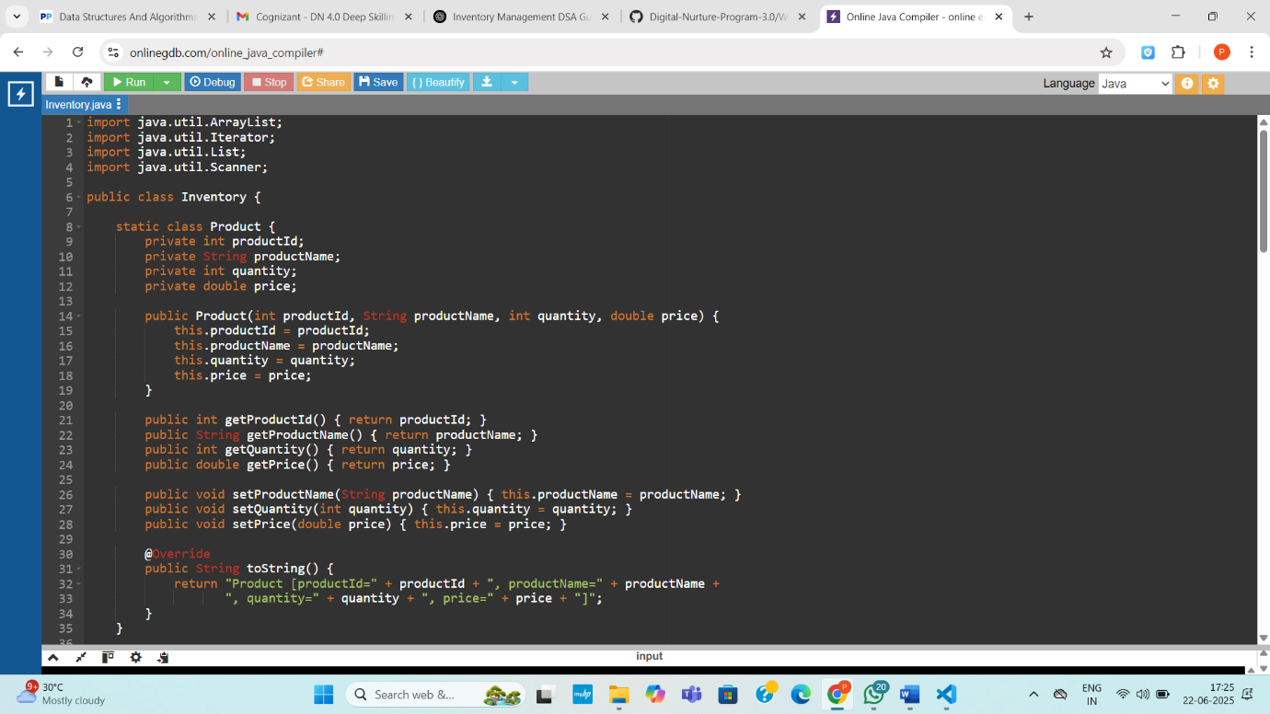

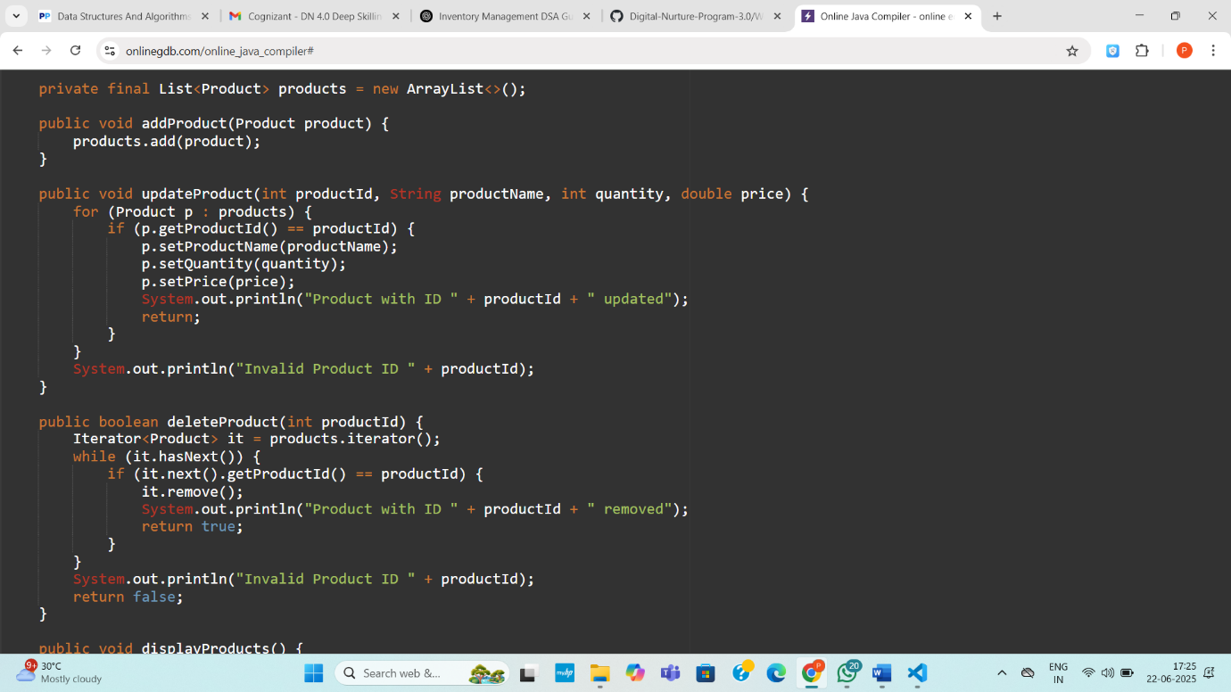

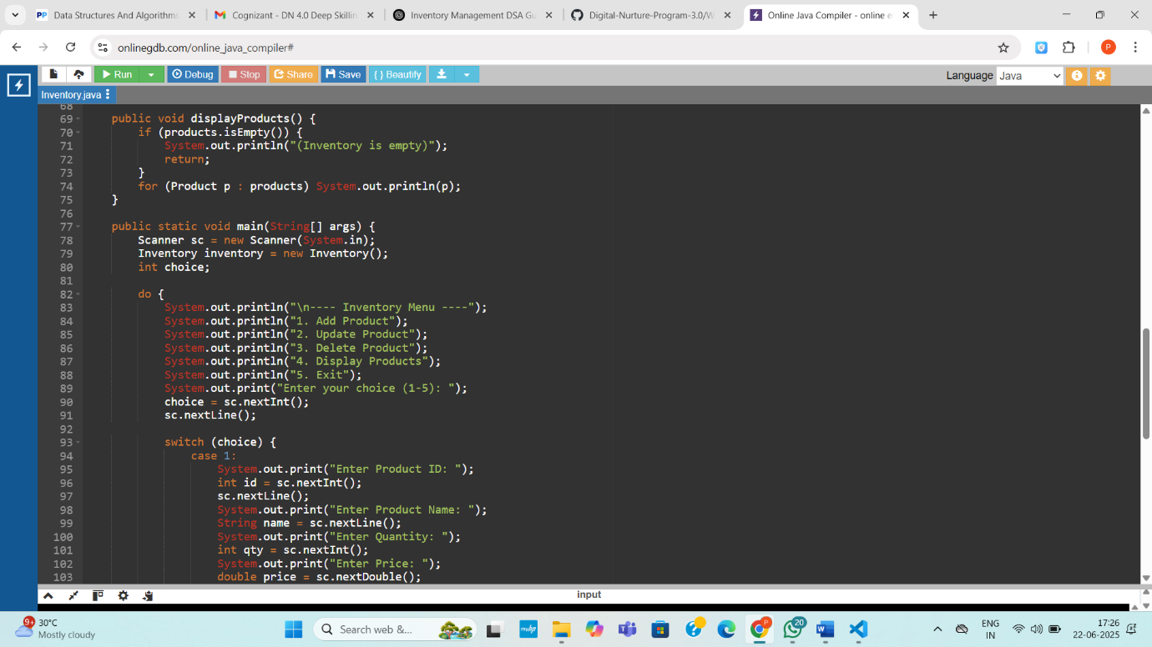

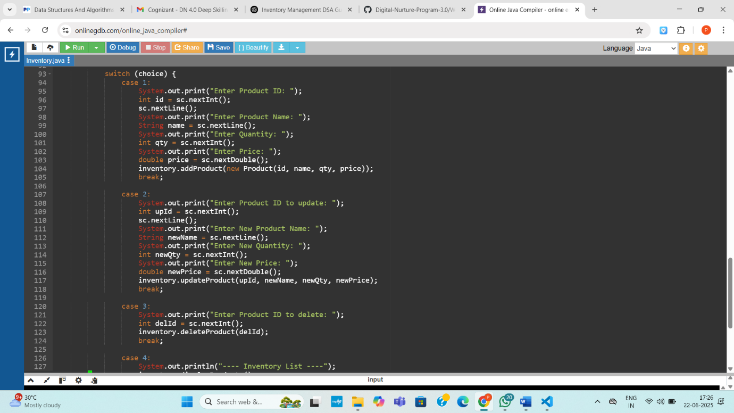

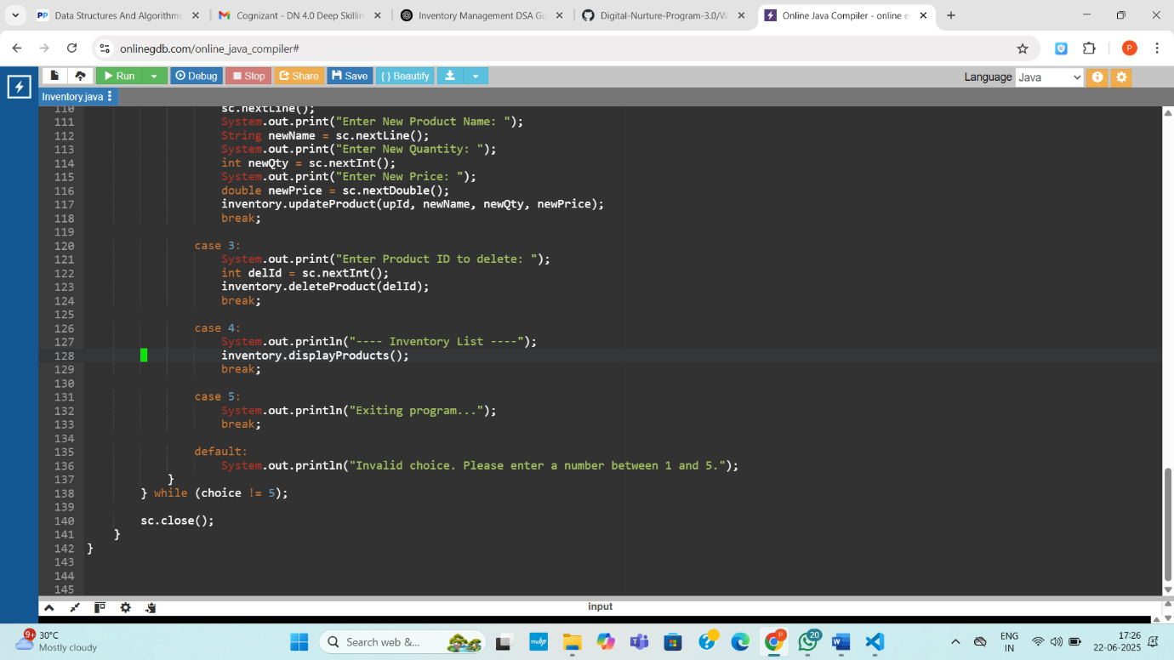

**Output:**

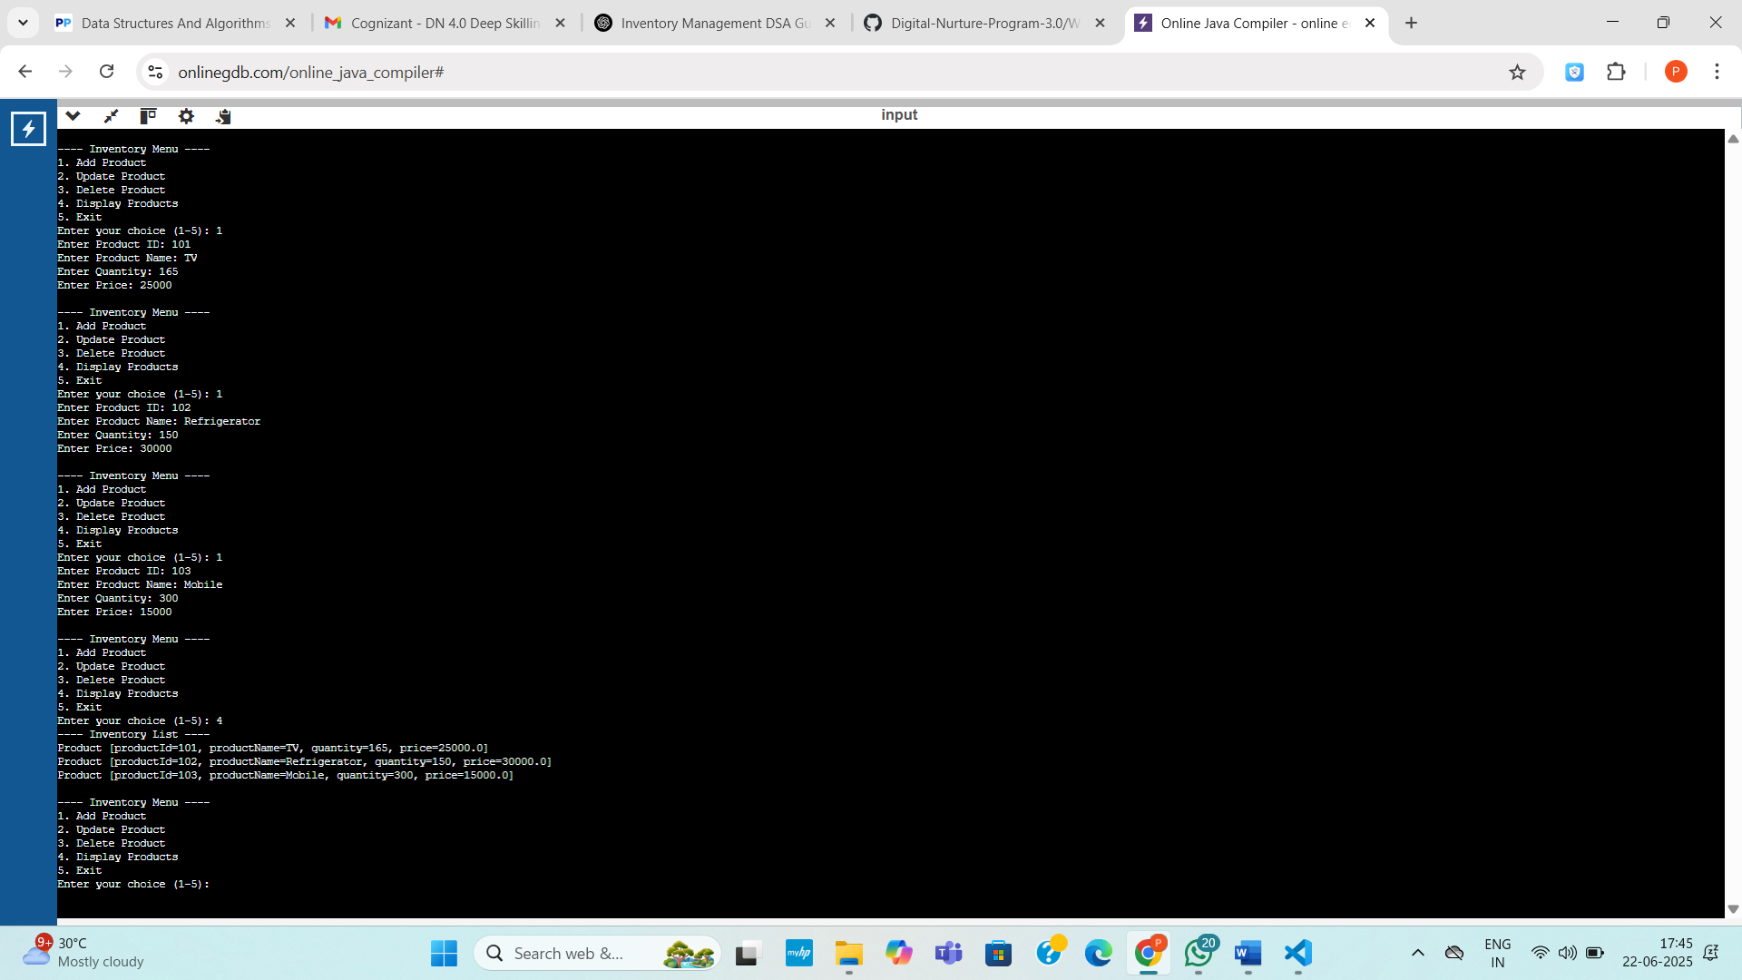

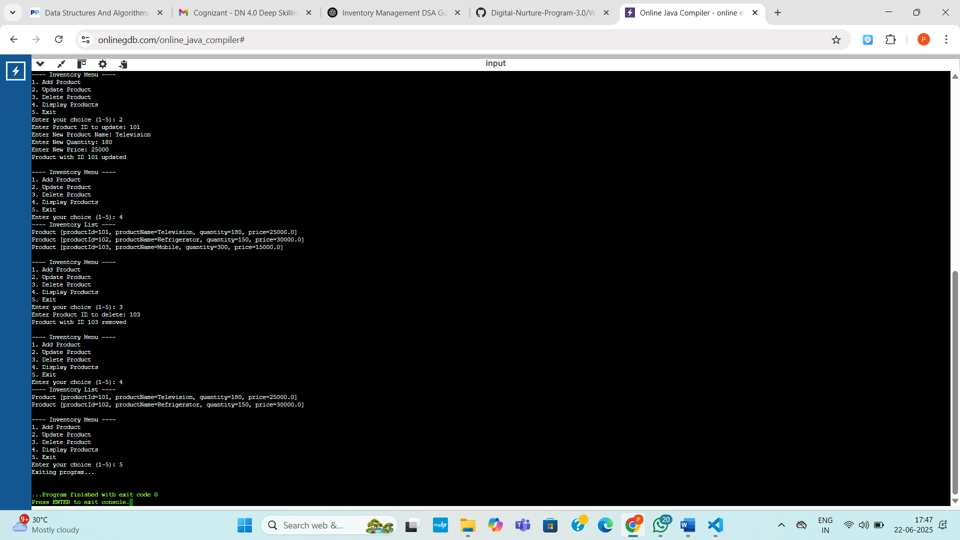

**Exercise 7: Financial Forecasting (Mandatory)**

**Code:**

import java.util.Scanner;

public class FinancialForecasting {

// Recursive method to calculate future value

public static double calculateFutureValue(double principal, double rate, int years) {

if (years == 0)

return principal;

return (1 + rate) * calculateFutureValue(principal, rate, years - 1);

}

public static void main(String[] args) {

Scanner sc = new Scanner(System.in);

System.out.println("--- Financial Forecasting Tool ---");

System.out.print("Enter Present Value (Principal ₹): ");

double principal = sc.nextDouble();

System.out.print("Enter Annual Growth Rate (e.g., 8 for 8%): ");

double ratePercent = sc.nextDouble();

double rate = ratePercent / 100.0;

System.out.print("Enter Time in Years: ");

int years = sc.nextInt();

double futureValue = calculateFutureValue(principal, rate, years);

System.out.printf("\nFuture value after %d years = ₹%.2f\n", years, futureValue);

sc.close();

}

}

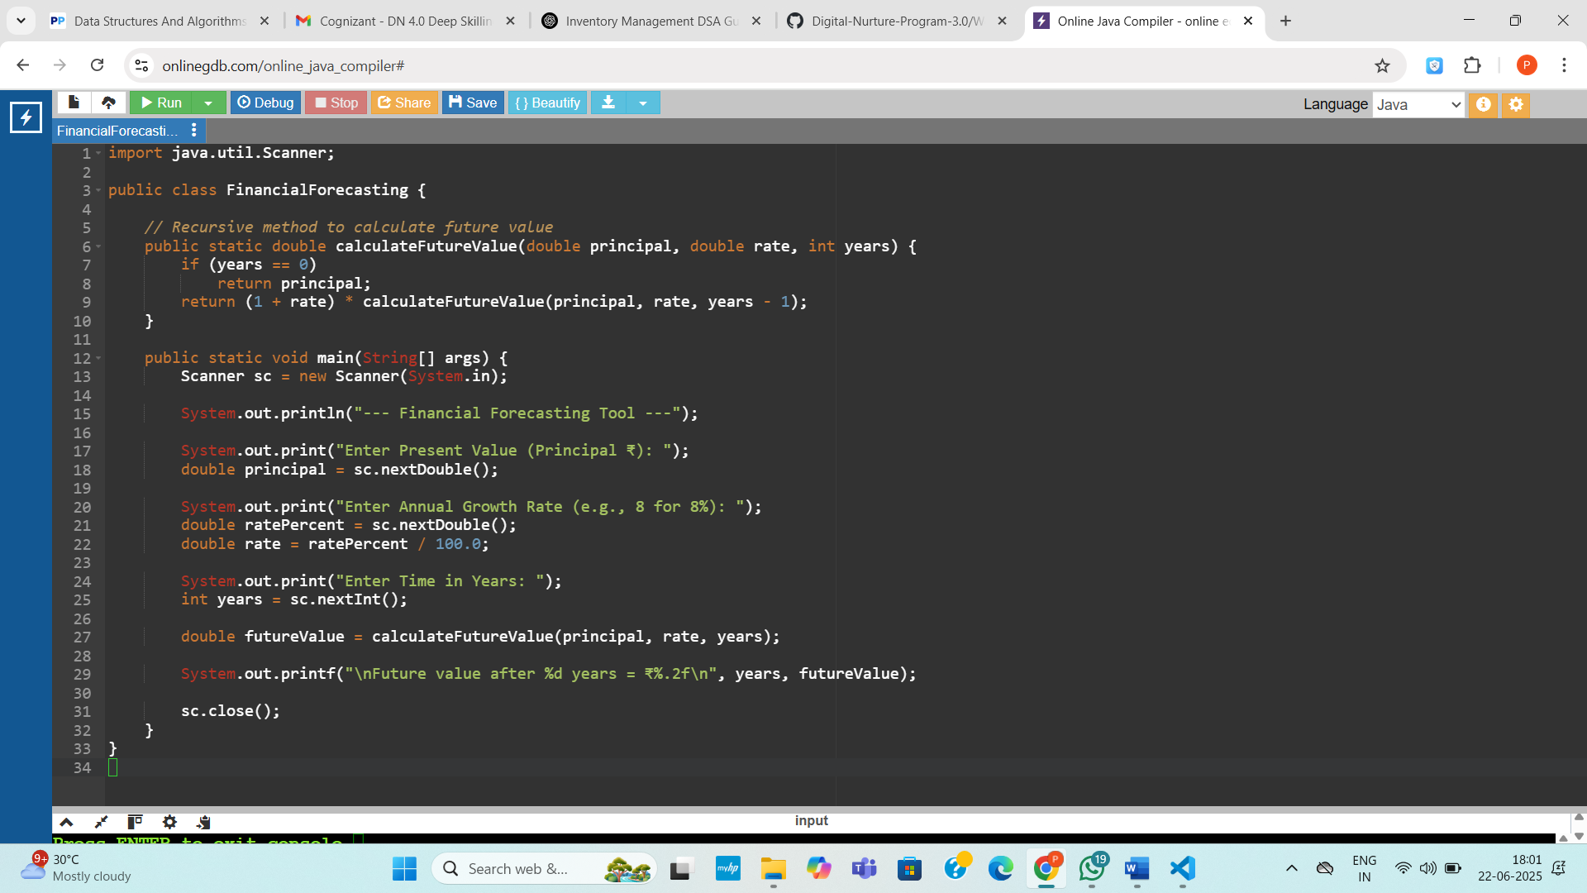

**Output:**

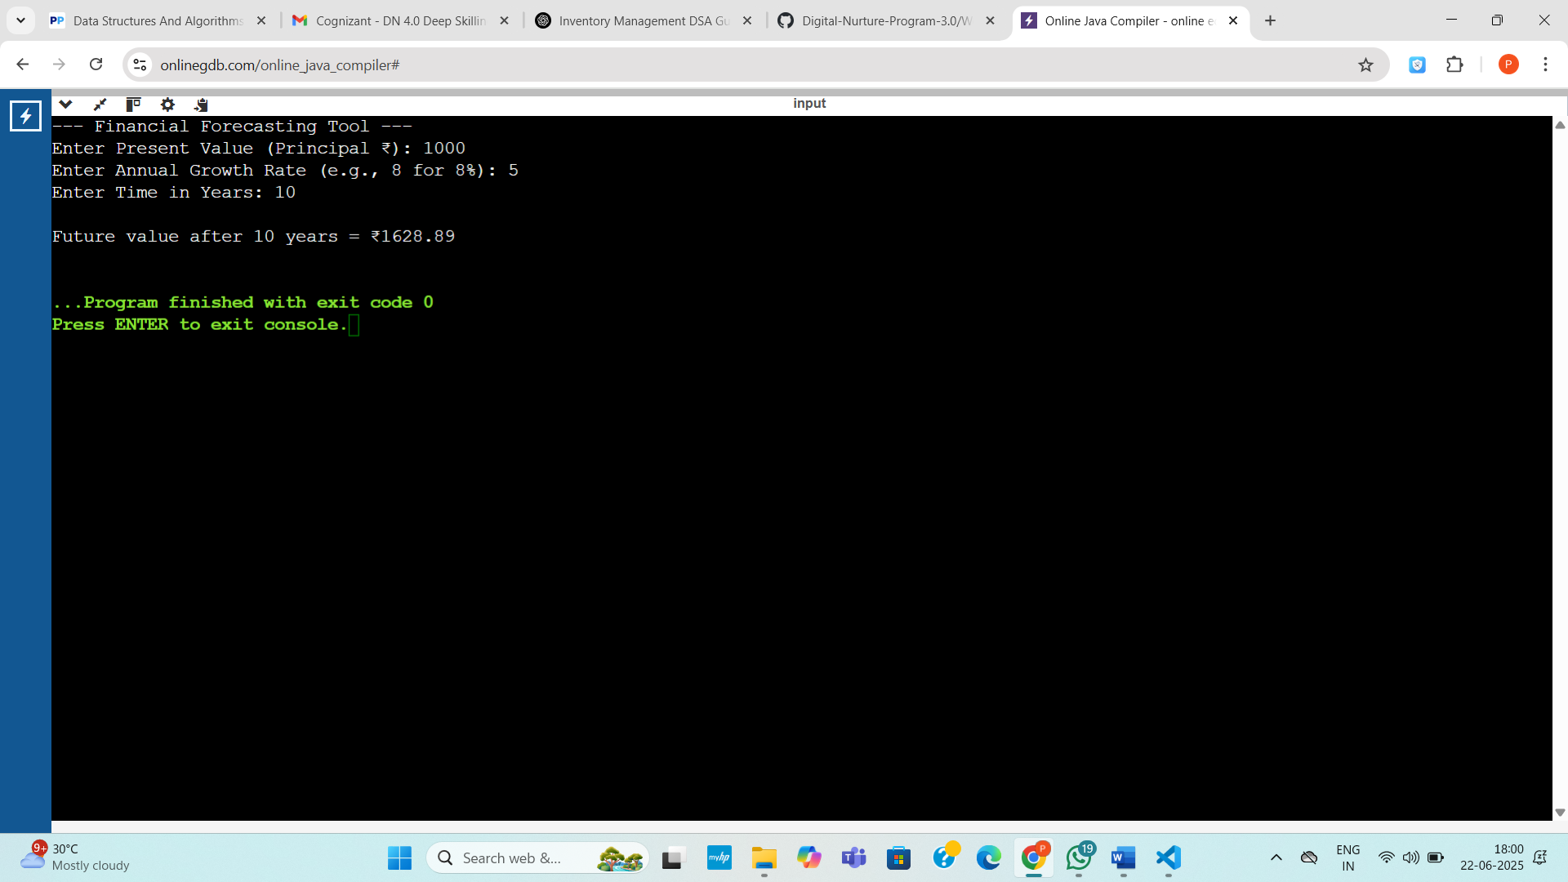

**Exercise 2: E-commerce Platform Search Function**

Code:

import java.util.Arrays;

public class SearchDemo {

static class Product {

int productId;

String productName;

String category;

Product(int id, String name, String cat) {

productId = id;

productName = name;

category = cat;

}

@Override

public String toString() {

return productId + " | " + productName + " | " + category;

}

}

static Product linearSearch(Product[] arr, int key) {

for (Product p : arr) {

if (p.productId == key)

return p;

}

return null;

}

static Product binarySearch(Product[] arr, int key) {

int low = 0, high = arr.length - 1;

while (low <= high) {

int mid = (low + high) / 2;

if (arr[mid].productId == key)

return arr[mid];

else if (arr[mid].productId < key)

low = mid + 1;

else

high = mid - 1;

}

return null;

}

public static void main(String[] args) {

Product[] products = {

new Product(104, "T-Shirt", "Clothing"),

new Product(501, "Wireless Mouse", "Electronics"),

new Product(223, "Espresso Beans", "Grocery"),

new Product(317, "Yoga Mat", "Fitness"),

new Product(410, "LED Bulb", "Home")

};

int searchId1 = 223;

Product result1 = linearSearch(products, searchId1);

if (result1 != null)

System.out.println("Linear Search Found: " + result1);

else

System.out.println("Product not found with ID " + searchId1);

Arrays.sort(products, (a, b) -> a.productId - b.productId);

int searchId2 = 223;

Product result2 = binarySearch(products, searchId2);

if (result2 != null)

System.out.println("Binary Search Found: " + result2);

else

System.out.println("Product not found with ID " + searchId2);

}

}

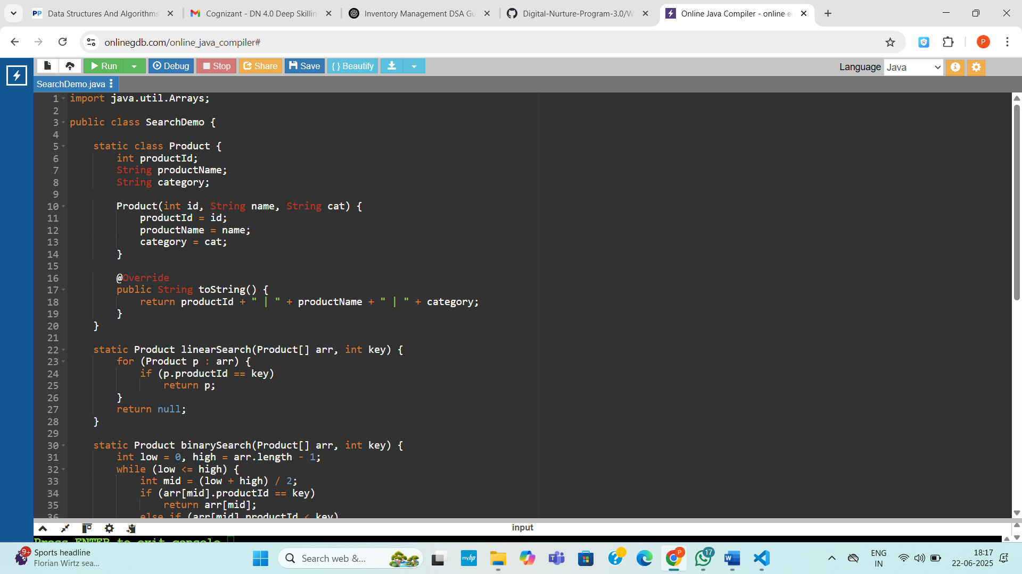

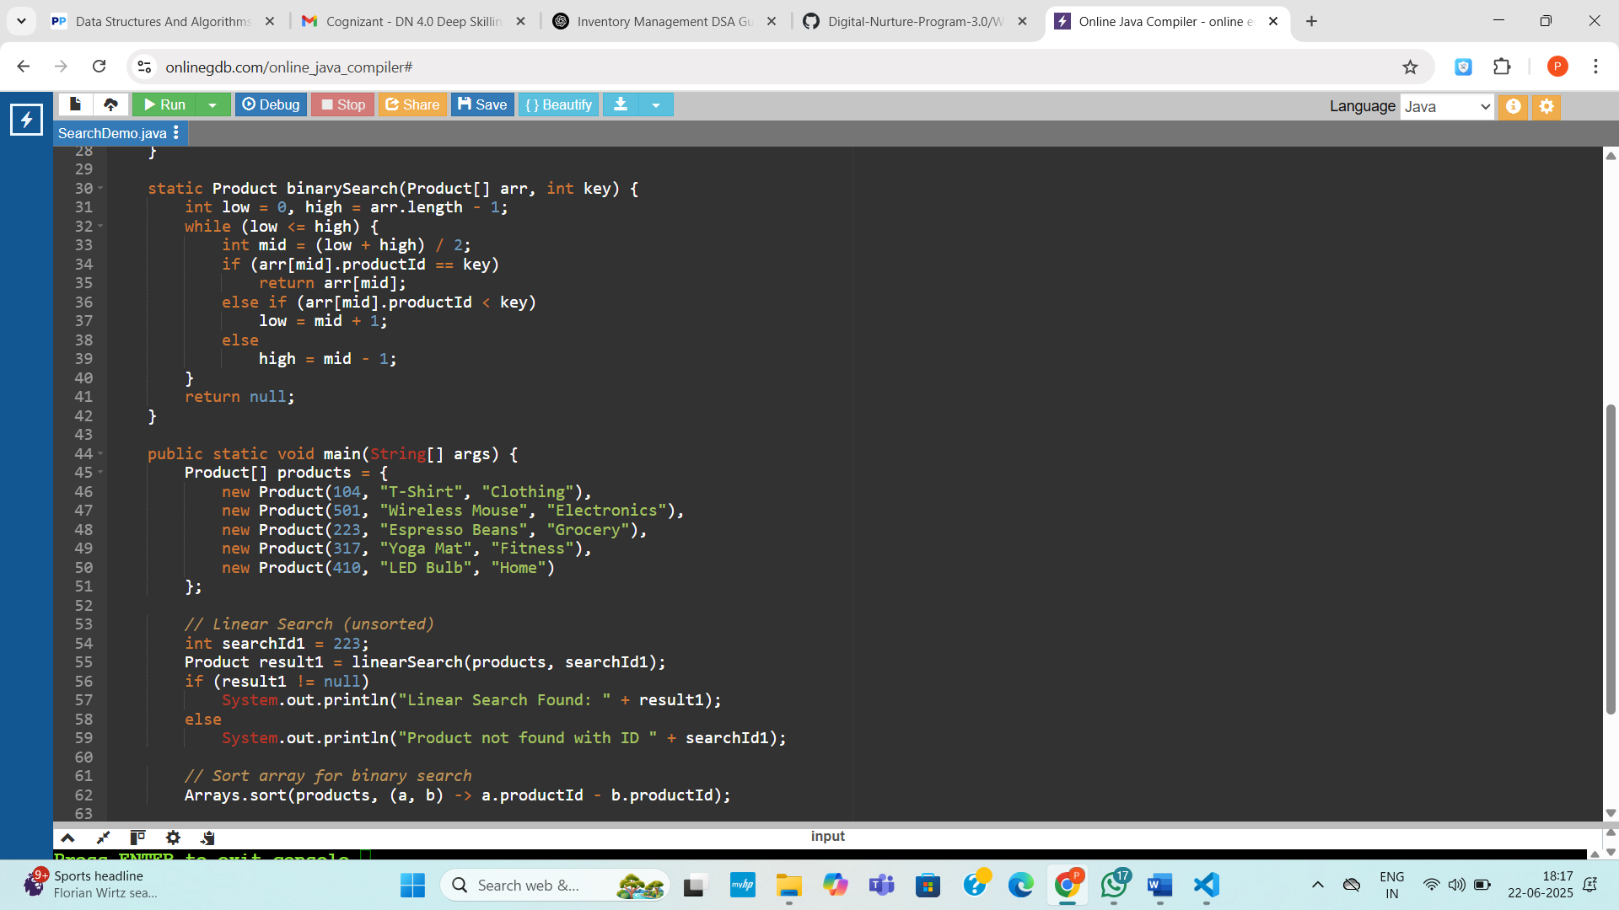

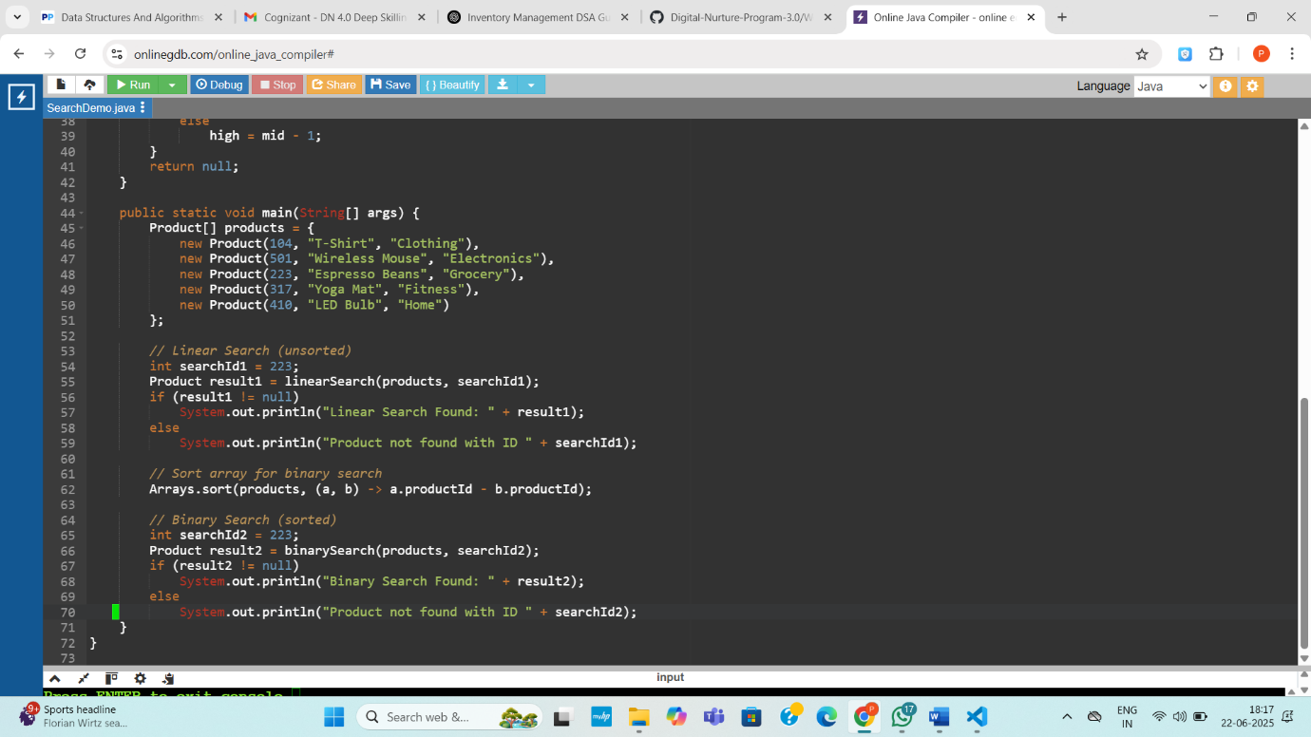

**Output:**

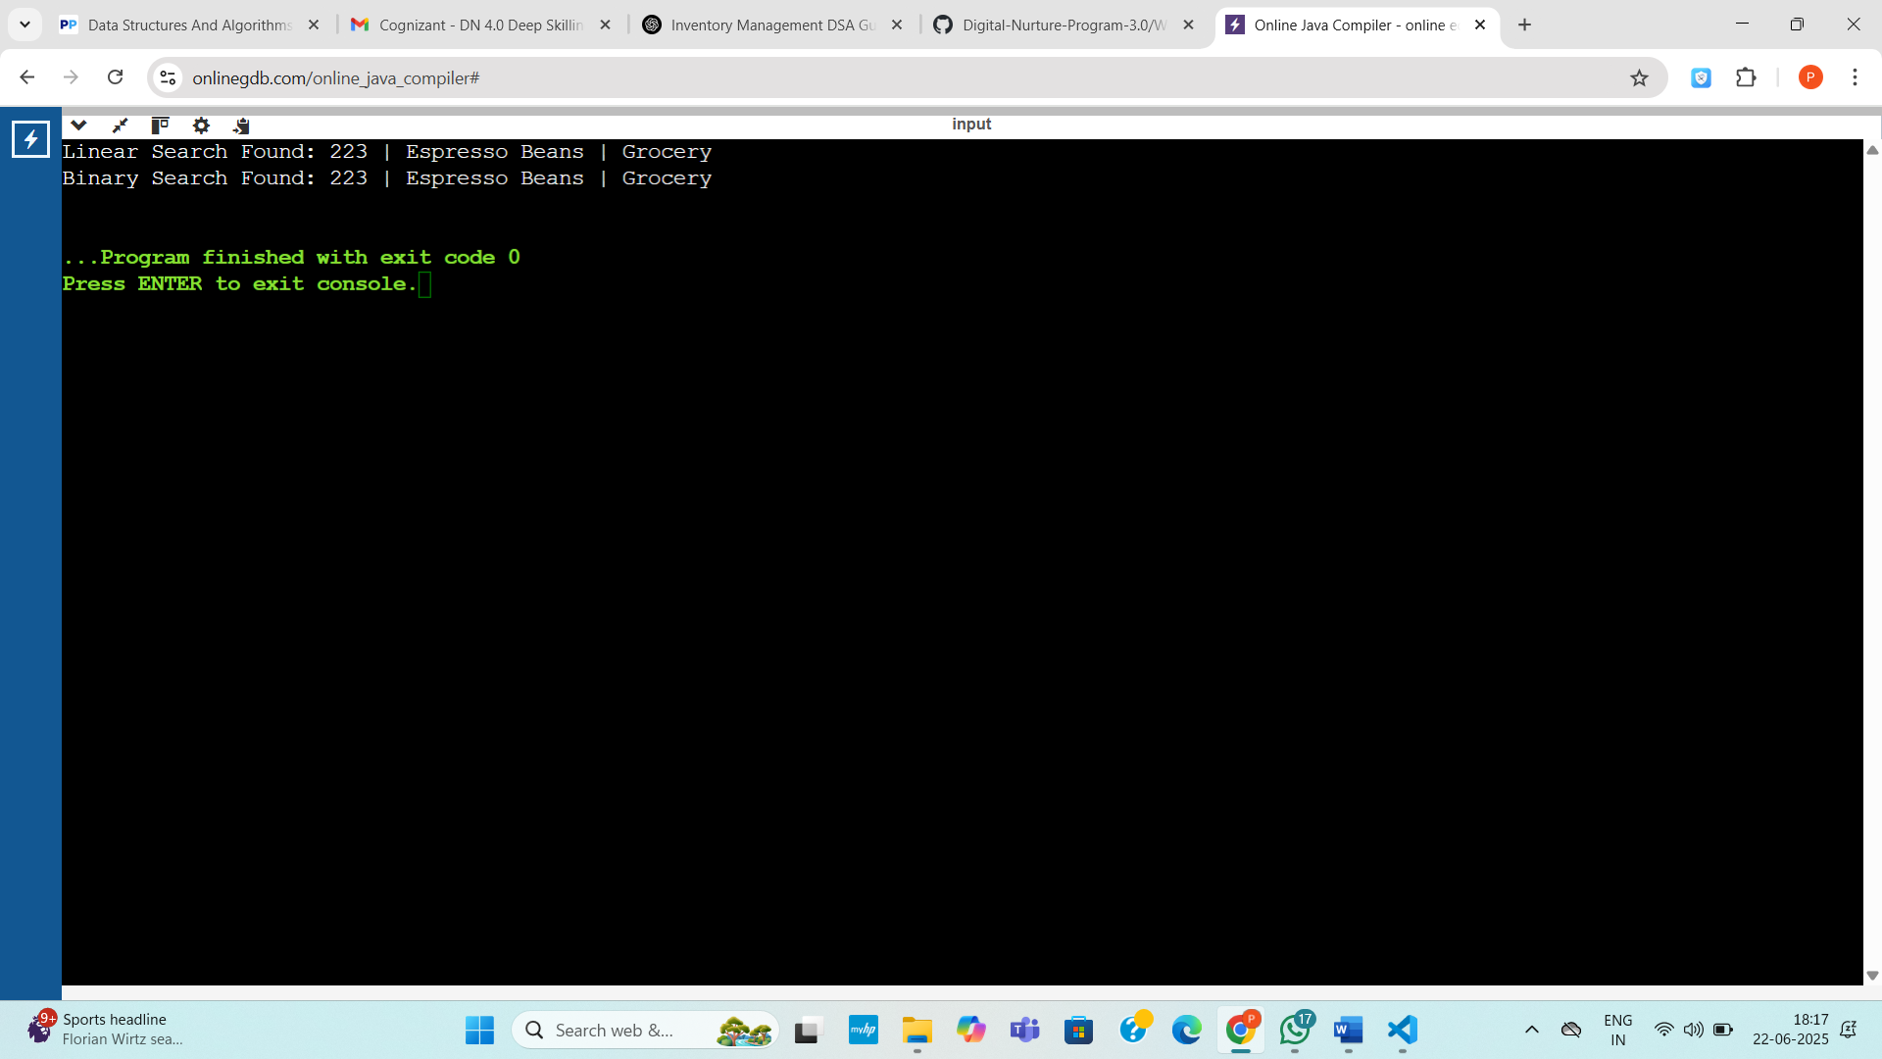

**Exercise 3: Sorting Customer Orders**

**Code:**

import java.util.Arrays;

public class OrderSortDemo {

static class Order {

int orderId;

String customerName;

double totalPrice;

Order(int id, String name, double price) {

orderId = id;

customerName = name;

totalPrice = price;

}

public String toString() {

return orderId + " | " + customerName + " | ₹" + totalPrice;

}

}

static void bubbleSort(Order[] arr) {

int n = arr.length;

boolean swapped;

do {

swapped = false;

for (int i = 1; i < n; i++) {

if (arr[i - 1].totalPrice < arr[i].totalPrice) {

Order temp = arr[i - 1];

arr[i - 1] = arr[i];

arr[i] = temp;

swapped = true;

}

}

n--;

} while (swapped);

}

static void quickSort(Order[] arr) {

quickSort(arr, 0, arr.length - 1);

}

static void quickSort(Order[] arr, int low, int high) {

if (low >= high) return;

double pivot = arr[(low + high) / 2].totalPrice;

int i = low, j = high;

while (i <= j) {

while (arr[i].totalPrice > pivot) i++;

while (arr[j].totalPrice < pivot) j--;

if (i <= j) {

Order temp = arr[i];

arr[i] = arr[j];

arr[j] = temp;

i++;

j--;

}

}

quickSort(arr, low, j);

quickSort(arr, i, high);

}

public static void main(String[] args) {

Order[] orders = {

new Order(1001, "Priya", 5499.0),

new Order(1002, "Rahul", 12999.5),

new Order(1005, "Anika", 4599.0),

new Order(1008, "Meera", 799.0),

new Order(1010, "Sahil", 24999.9)

};

Order[] copy1 = Arrays.copyOf(orders, orders.length);

Order[] copy2 = Arrays.copyOf(orders, orders.length);

bubbleSort(copy1);

quickSort(copy2);

System.out.println("Bubble Sort (high to low totalPrice):");

for (Order o : copy1) System.out.println(o);

System.out.println("\nQuick Sort (high to low totalPrice):");

for (Order o : copy2) System.out.println(o);

}

}

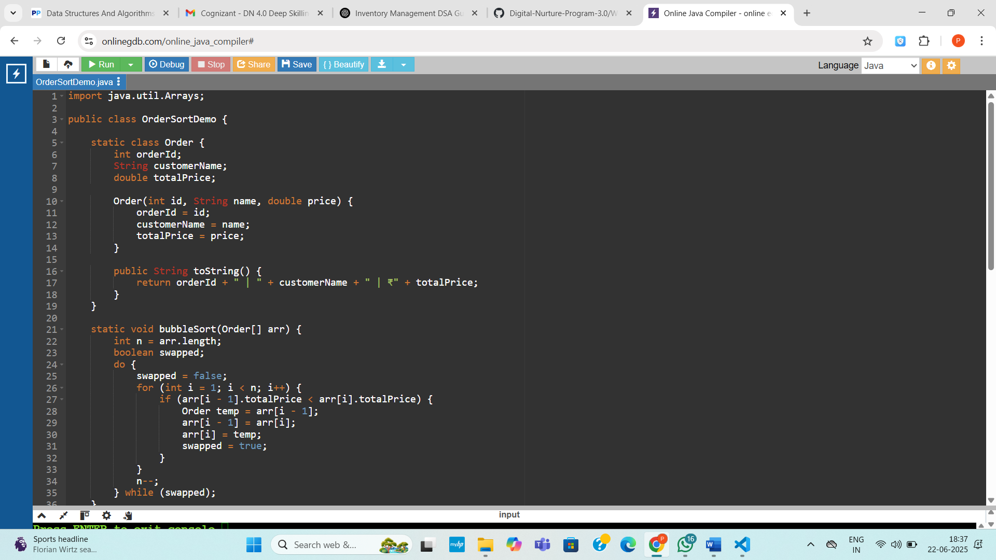

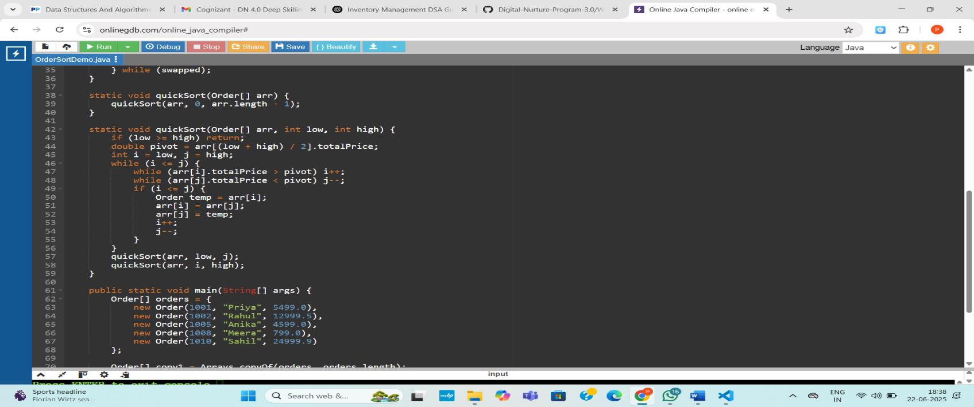

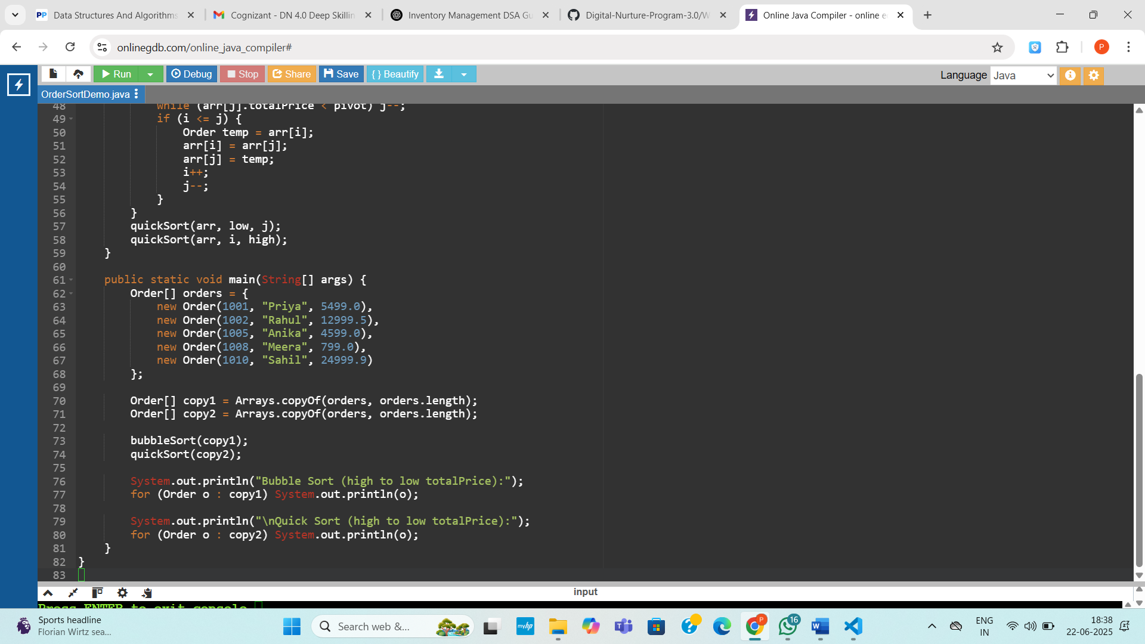

**Output:**

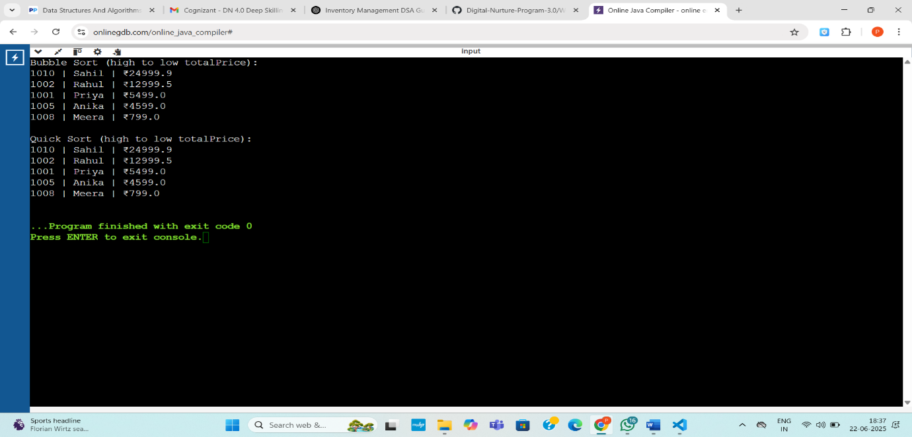

**Exercise 4: Employee Management System**

import java.util.ArrayList;

import java.util.Scanner;

public class EmployeeManagementSystem {

static class Employee {

int employeeId;

String employeeName;

String designation;

double salary;

Employee(int id, String name, String role, double sal) {

employeeId = id;

employeeName = name;

designation = role;

salary = sal;

}

public String toString() {

return employeeId + " | " + employeeName + " | " + designation + " | ₹" + salary;

}

}

static ArrayList<Employee> employees = new ArrayList<>();

static void addEmployee(Employee emp) {

employees.add(emp);

}

static void updateEmployee(int id, String name, String designation, double salary) {

for (Employee emp : employees) {

if (emp.employeeId == id) {

emp.employeeName = name;

emp.designation = designation;

emp.salary = salary;

System.out.println("Employee updated.");

return;

}

}

System.out.println("Employee ID not found.");

}

static void deleteEmployee(int id) {

for (Employee emp : employees) {

if (emp.employeeId == id) {

employees.remove(emp);

System.out.println("Employee deleted.");

return;

}

}

System.out.println("Employee ID not found.");

}

static void displayEmployees() {

if (employees.isEmpty()) {

System.out.println("No employee records.");

return;

}

for (Employee emp : employees)

System.out.println(emp);

}

public static void main(String[] args) {

Scanner sc = new Scanner(System.in);

int choice;

do {

System.out.println("\n--- Employee Management Menu ---");

System.out.println("1. Add Employee");

System.out.println("2. Update Employee");

System.out.println("3. Delete Employee");

System.out.println("4. Display All Employees");

System.out.println("5. Exit");

System.out.print("Enter your choice (1-5): ");

choice = sc.nextInt();

sc.nextLine();

switch (choice) {

case 1:

System.out.print("Enter Employee ID: ");

int id = sc.nextInt();

sc.nextLine();

System.out.print("Enter Name: ");

String name = sc.nextLine();

System.out.print("Enter Designation: ");

String desig = sc.nextLine();

System.out.print("Enter Salary: ");

double sal = sc.nextDouble();

addEmployee(new Employee(id, name, desig, sal));

break;

case 2:

System.out.print("Enter ID to update: ");

int uid = sc.nextInt();

sc.nextLine();

System.out.print("Enter New Name: ");

String newName = sc.nextLine();

System.out.print("Enter New Designation: ");

String newDesig = sc.nextLine();

System.out.print("Enter New Salary: ");

double newSal = sc.nextDouble();

updateEmployee(uid, newName, newDesig, newSal);

break;

case 3:

System.out.print("Enter ID to delete: ");

int did = sc.nextInt();

deleteEmployee(did);

break;

case 4:

System.out.println("--- Employee Records ---");

displayEmployees();

break;

case 5:

System.out.println("Exiting system...");

break;

default:

System.out.println("Invalid choice.");

}

} while (choice != 5);

sc.close();

}

}

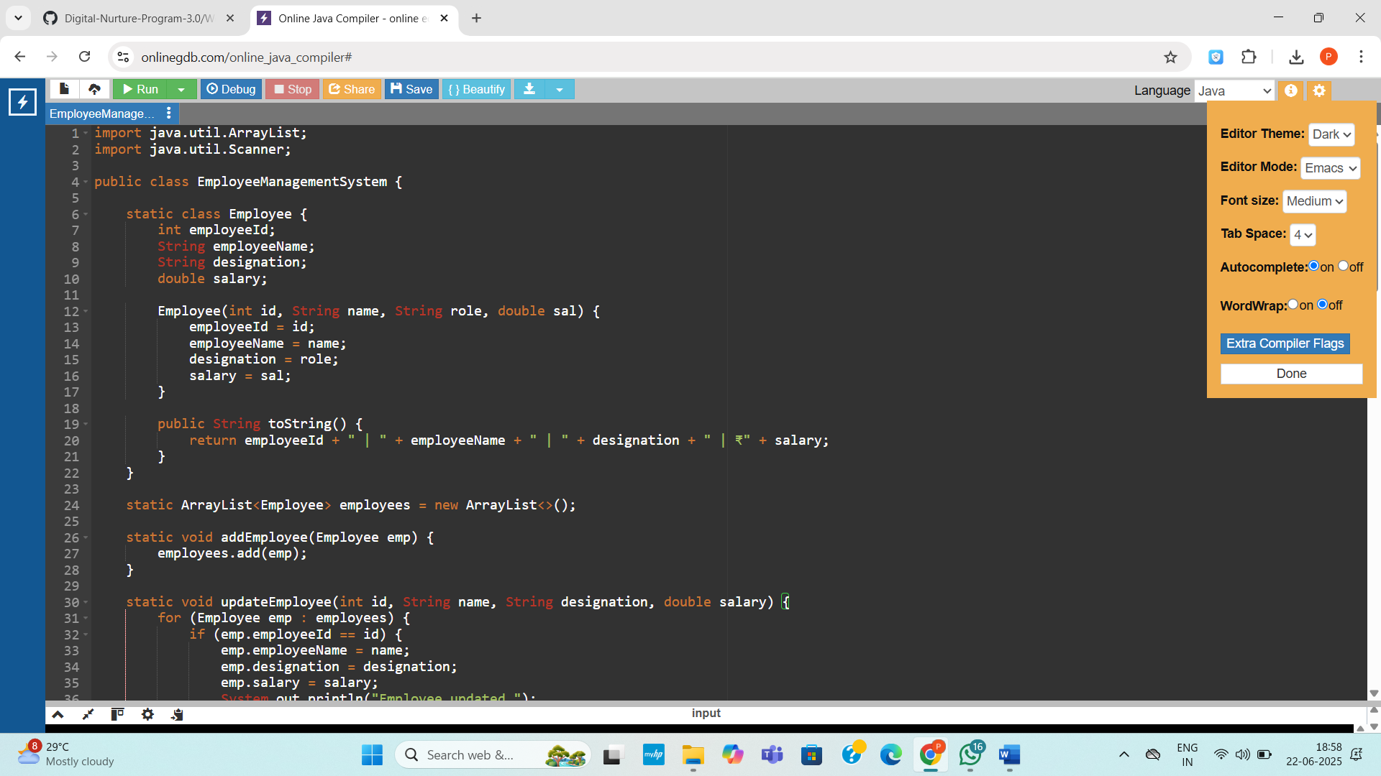

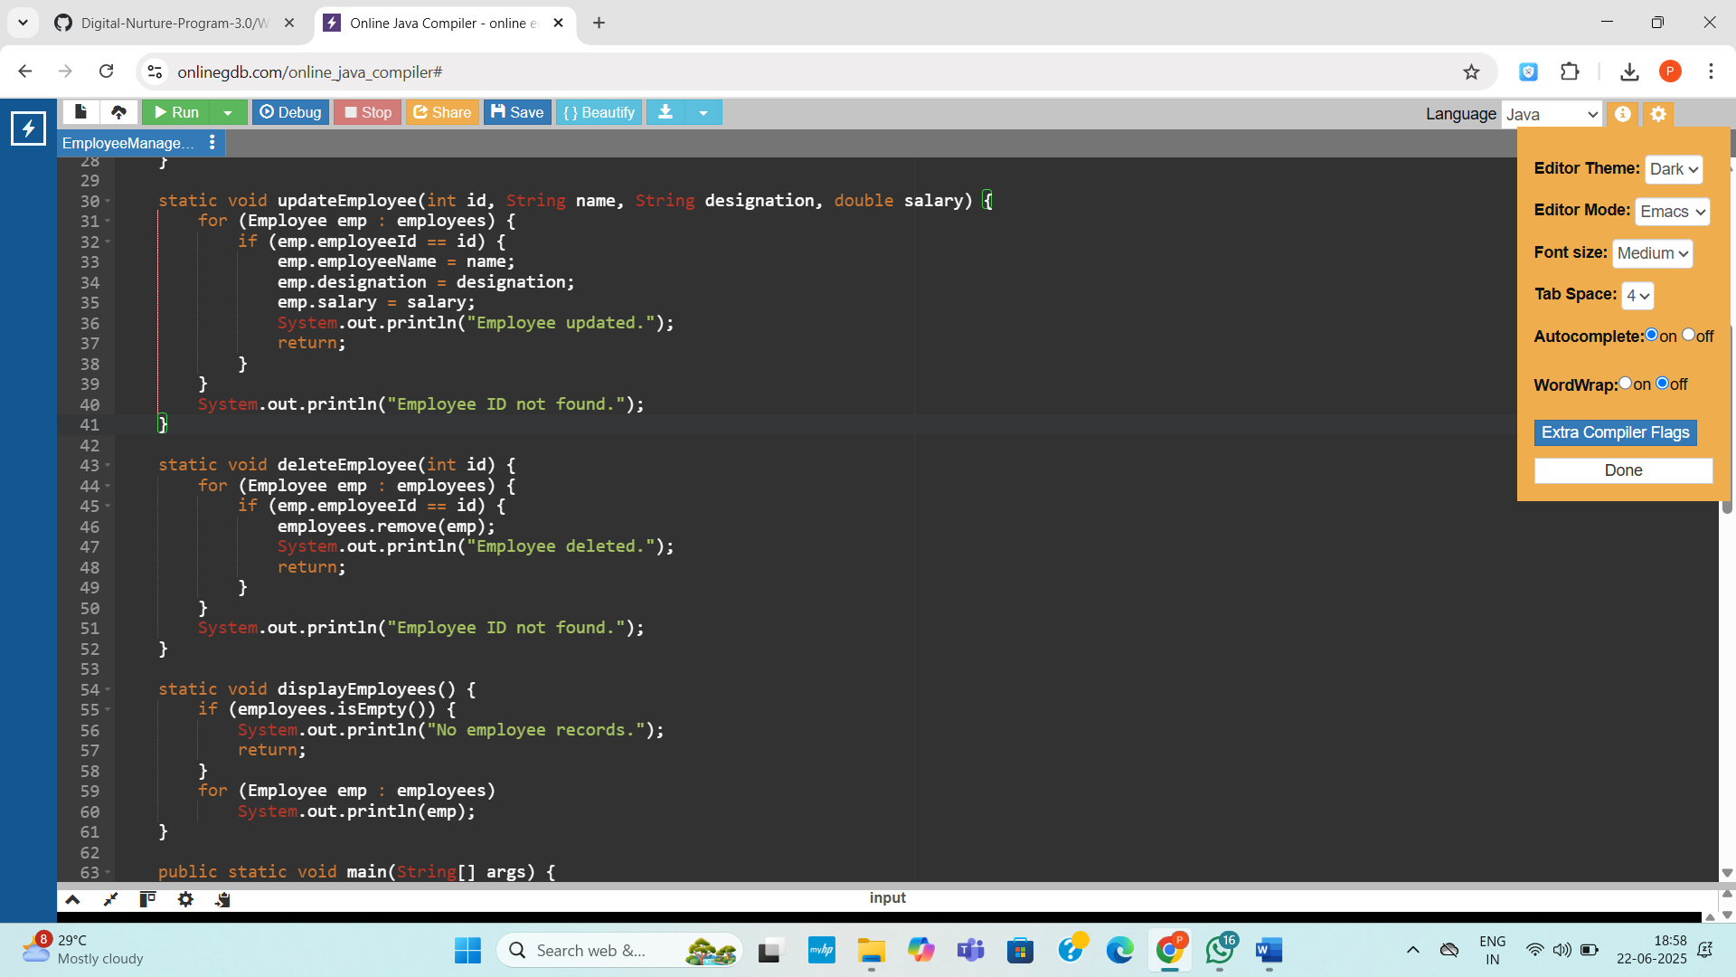

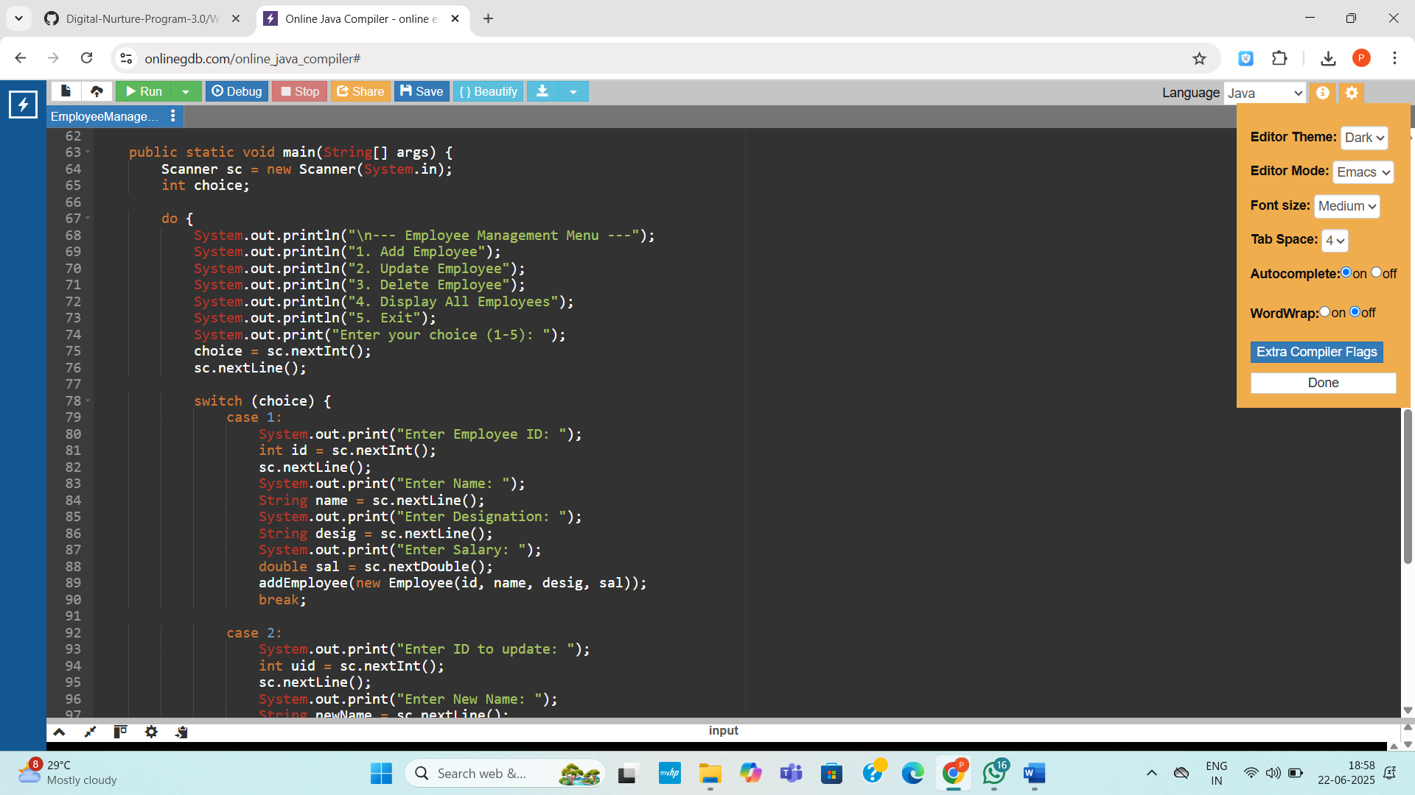

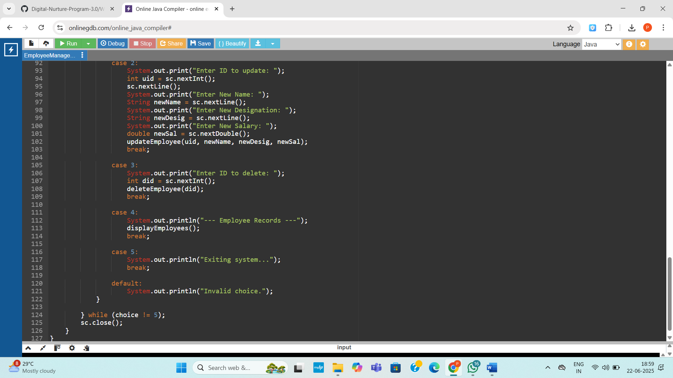

**Output:**

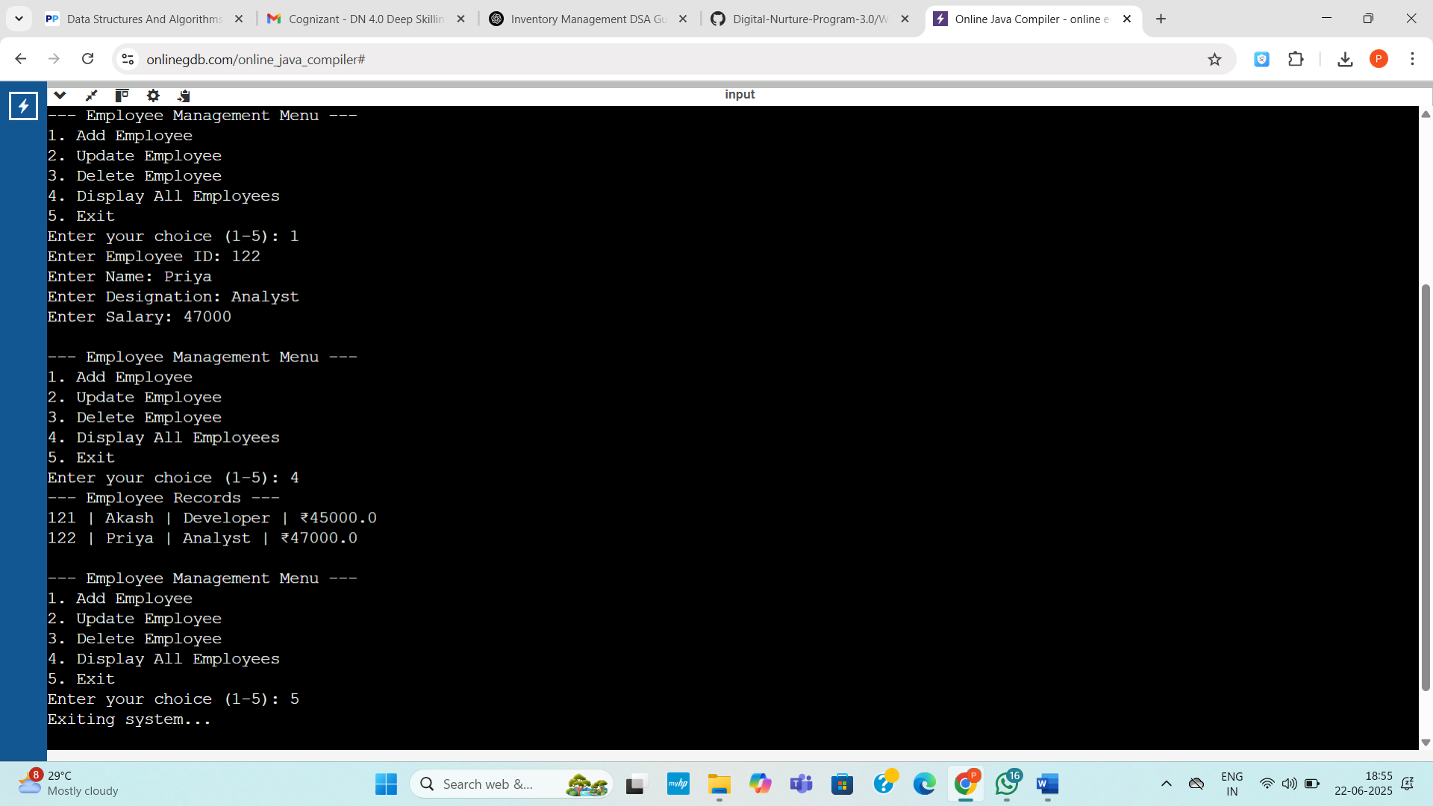

**Exercise 5: Task Management System**

**Code:**

import java.util.Scanner;

public class TaskManager {

static class Task {

int taskId;

String taskName;

String status;

Task next;

Task(int id, String name, String status) {

taskId = id;

taskName = name;

this.status = status;

next = null;

}

public String toString() {

return taskId + " | " + taskName + " | " + status;

}

}

static class TaskLinkedList {

Task head;

void addTask(int id, String name, String status) {

Task newTask = new Task(id, name, status);

if (head == null) {

head = newTask;

} else {

Task temp = head;

while (temp.next != null)

temp = temp.next;

temp.next = newTask;

}

}

void deleteTask(int id) {

if (head == null) {

System.out.println("List is empty.");

return;

}

if (head.taskId == id) {

head = head.next;

System.out.println("Task deleted.");

return;

}

Task curr = head;

while (curr.next != null && curr.next.taskId != id) {

curr = curr.next;

}

if (curr.next != null) {

curr.next = curr.next.next;

System.out.println("Task deleted.");

} else {

System.out.println("Task ID not found.");

}

}

void searchTask(int id) {

Task temp = head;

while (temp != null) {

if (temp.taskId == id) {

System.out.println("Found: " + temp);

return;

}

temp = temp.next;

}

System.out.println("Task ID not found.");

}

void displayTasks() {

if (head == null) {

System.out.println("No tasks.");

return;

}

Task temp = head;

while (temp != null) {

System.out.println(temp);

temp = temp.next;

}

}

}

public static void main(String[] args) {

Scanner sc = new Scanner(System.in);

TaskLinkedList list = new TaskLinkedList();

int choice;

do {

System.out.println("\n--- Task Manager Menu ---");

System.out.println("1. Add Task");

System.out.println("2. Delete Task");

System.out.println("3. Search Task");

System.out.println("4. Display All Tasks");

System.out.println("5. Exit");

System.out.print("Enter choice: ");

choice = sc.nextInt();

sc.nextLine();

switch (choice) {

case 1:

System.out.print("Task ID: ");

int id = sc.nextInt();

sc.nextLine();

System.out.print("Task Name: ");

String name = sc.nextLine();

System.out.print("Status (Pending/Done): ");

String status = sc.nextLine();

list.addTask(id, name, status);

break;

case 2:

System.out.print("Enter Task ID to delete: ");

int delId = sc.nextInt();

list.deleteTask(delId);

break;

case 3:

System.out.print("Enter Task ID to search: ");

int searchId = sc.nextInt();

list.searchTask(searchId);

break;

case 4:

System.out.println("All Tasks:");

list.displayTasks();

break;

case 5:

System.out.println("Exiting...");

break;

default:

System.out.println("Invalid choice.");

}

} while (choice != 5);

sc.close();

}

}

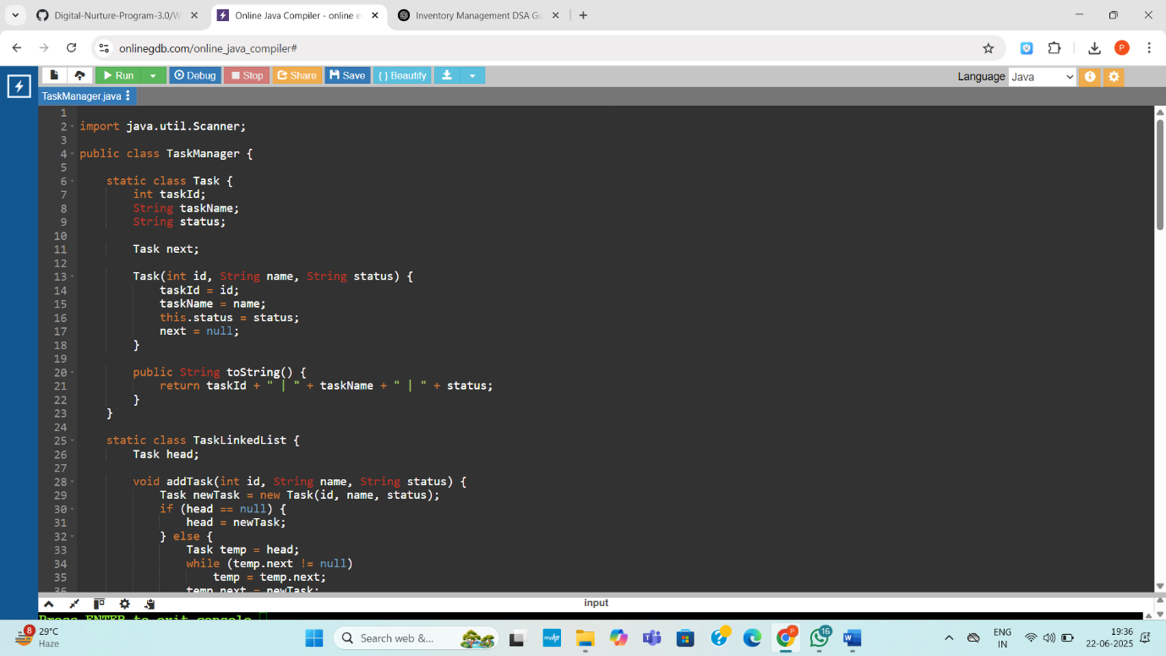

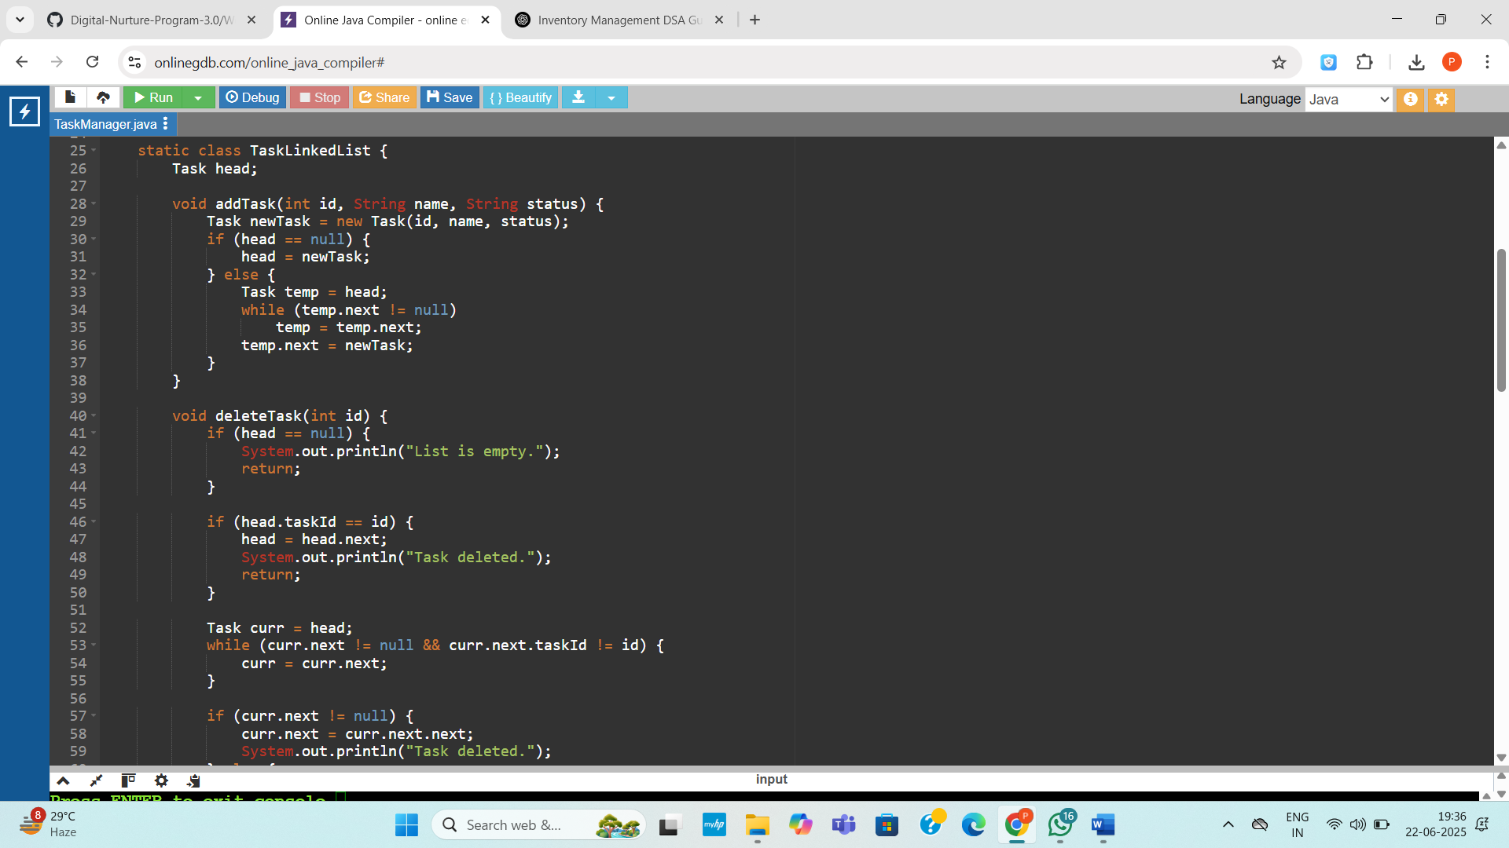

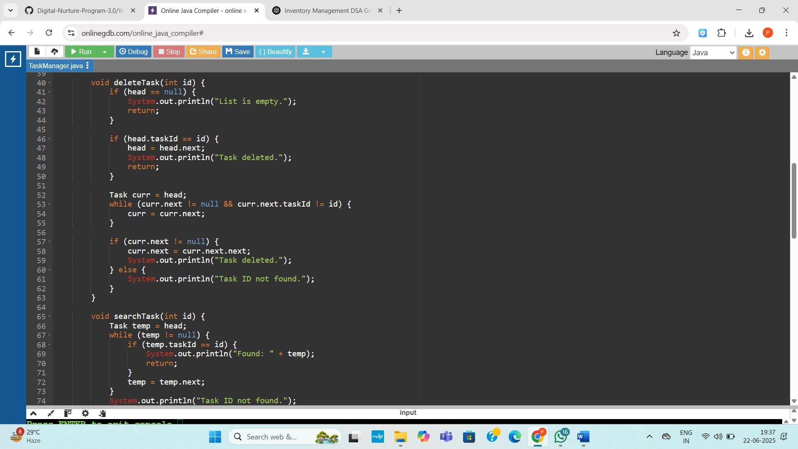

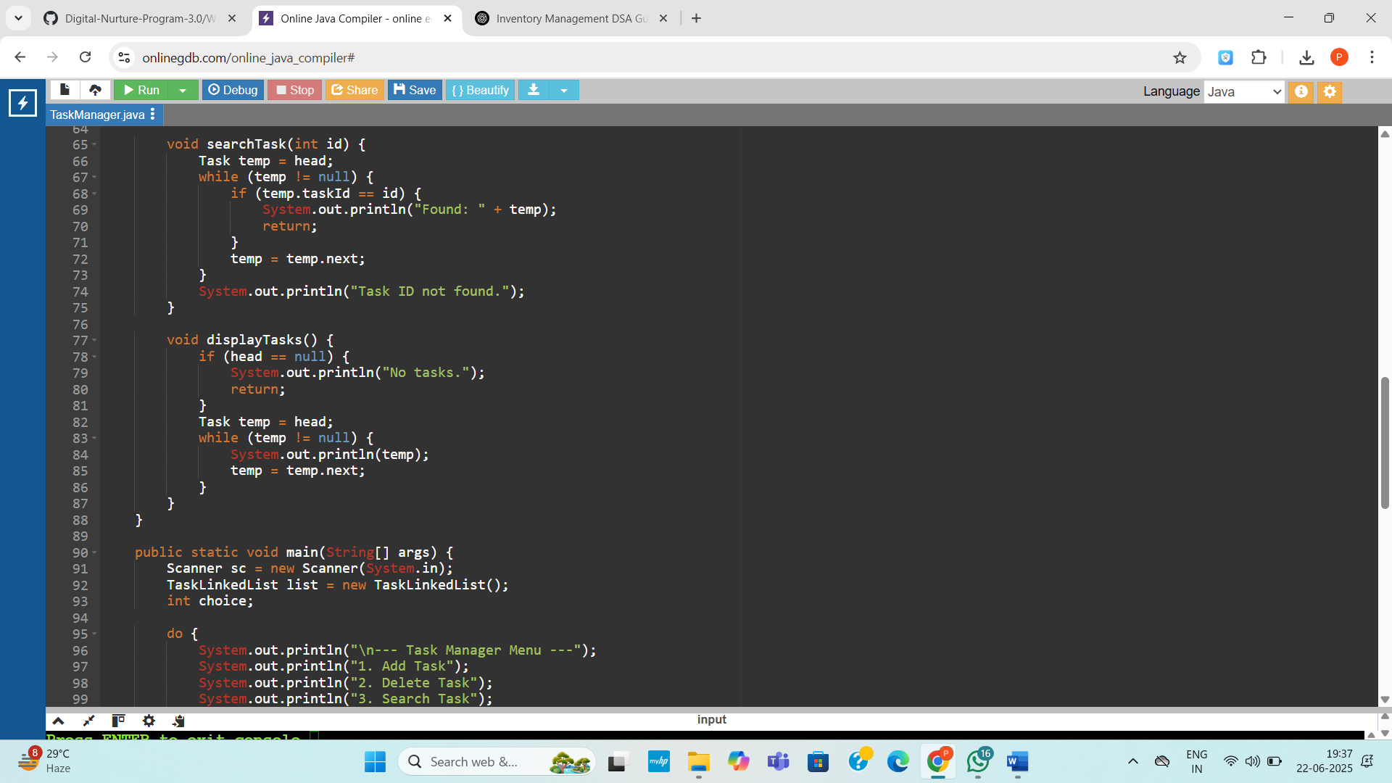

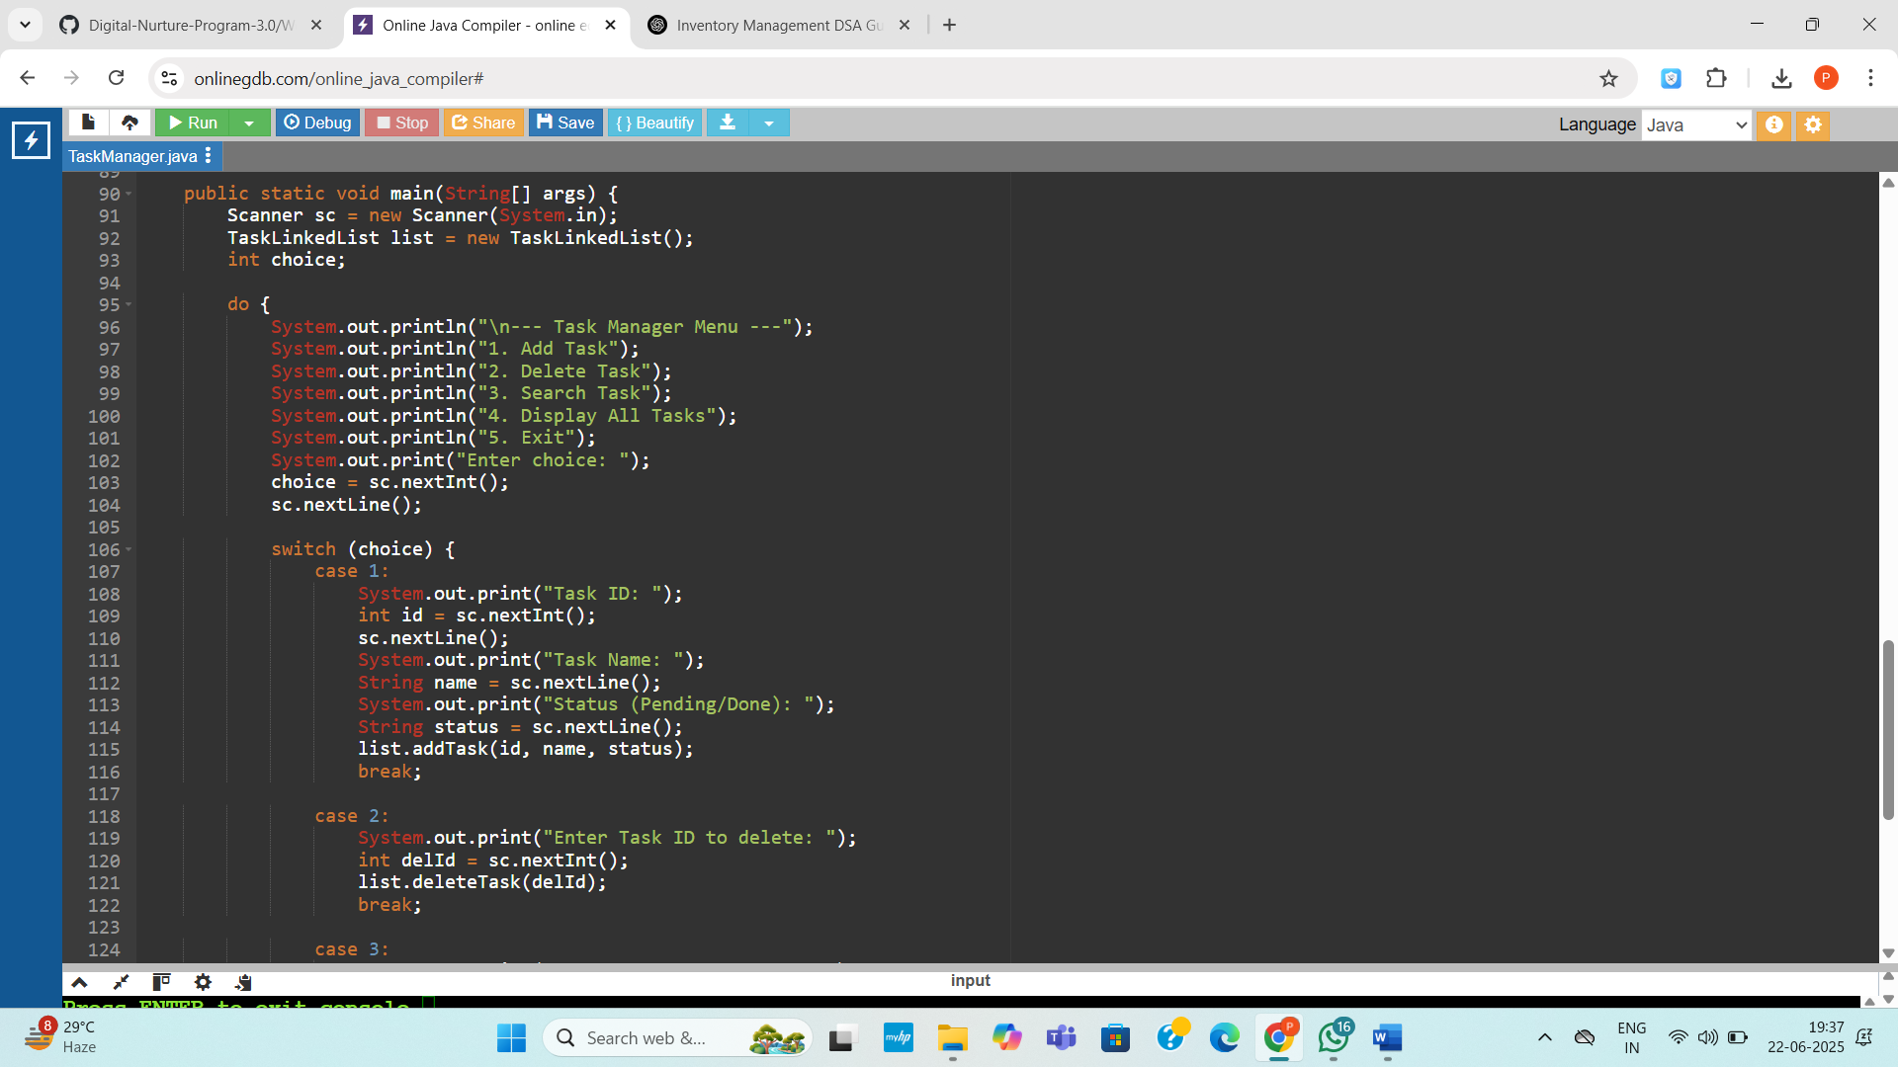

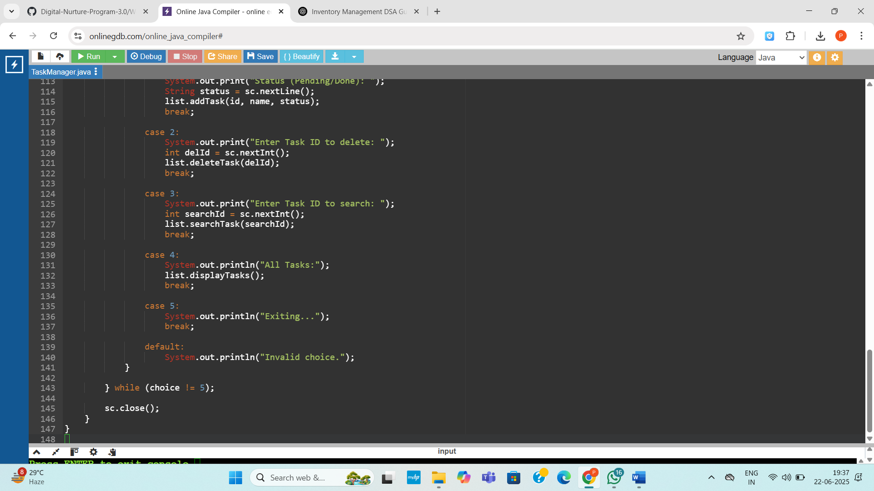

**Output:**

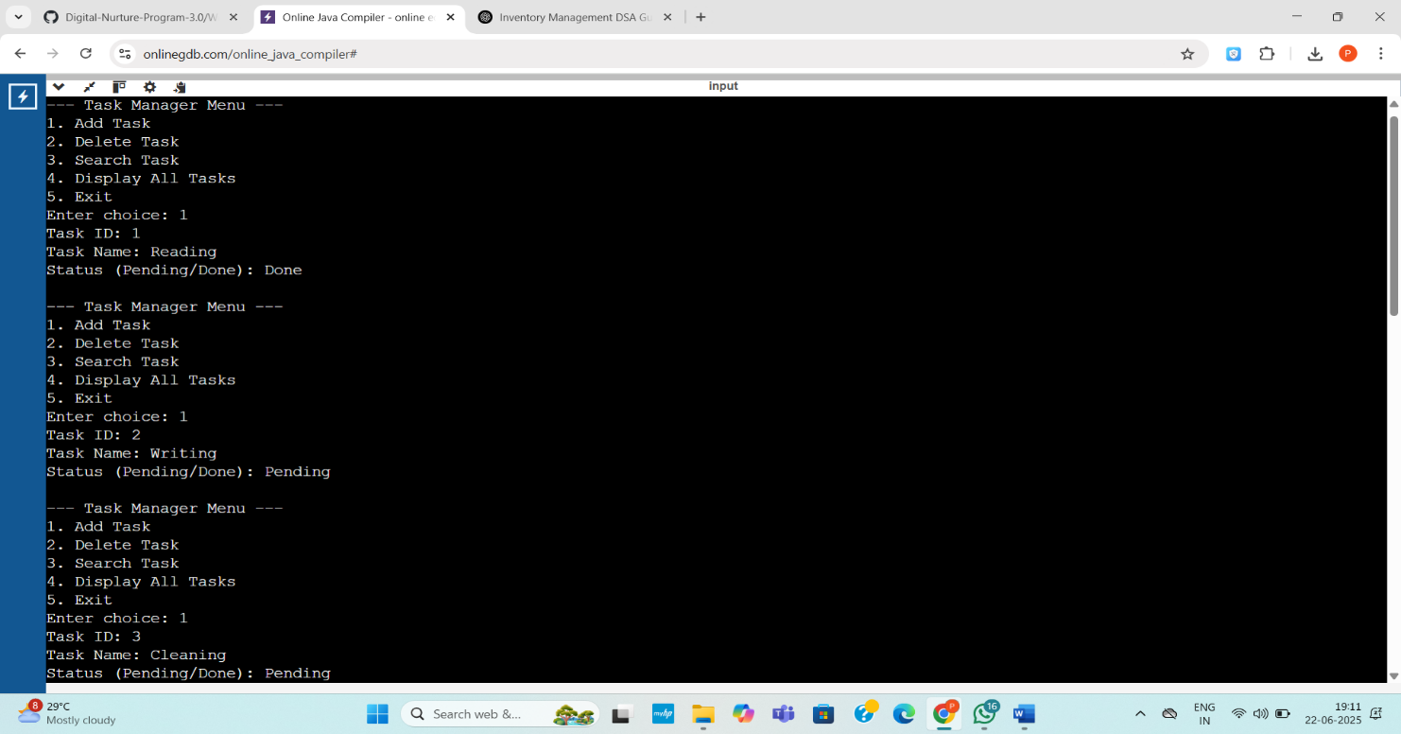

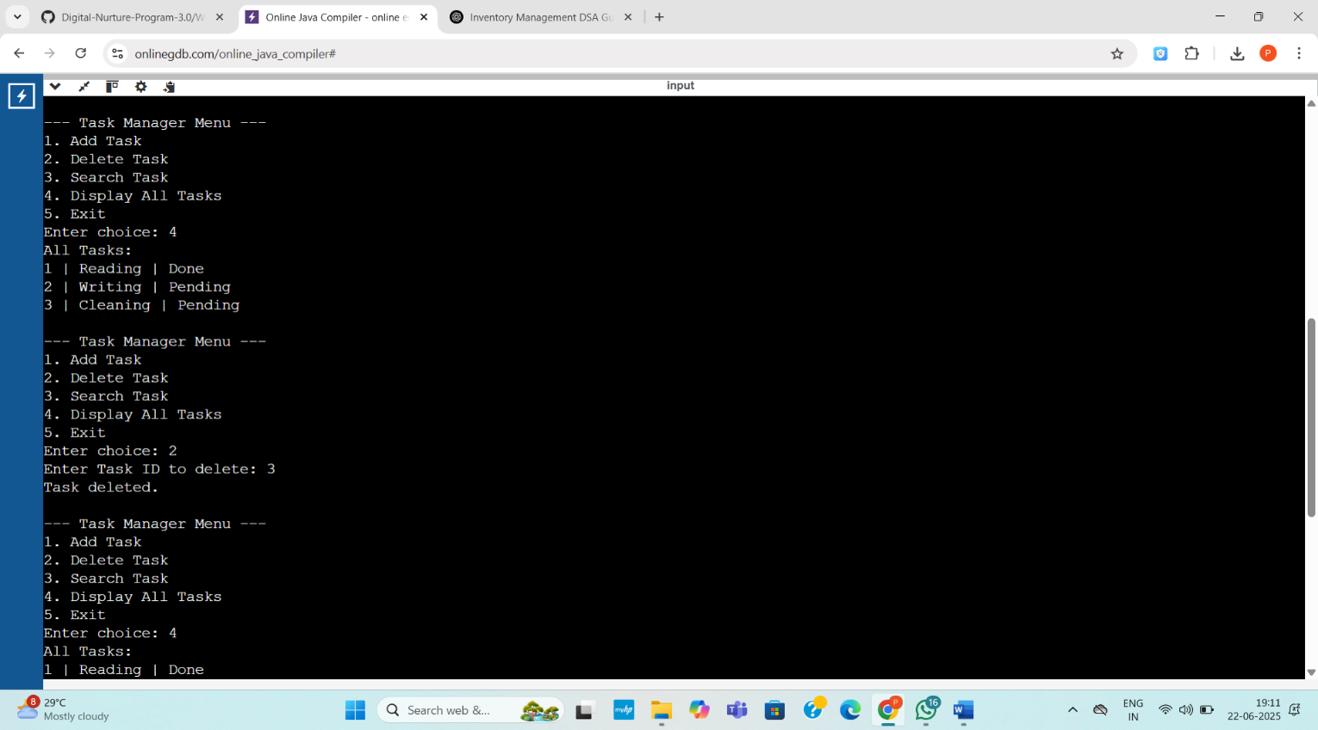

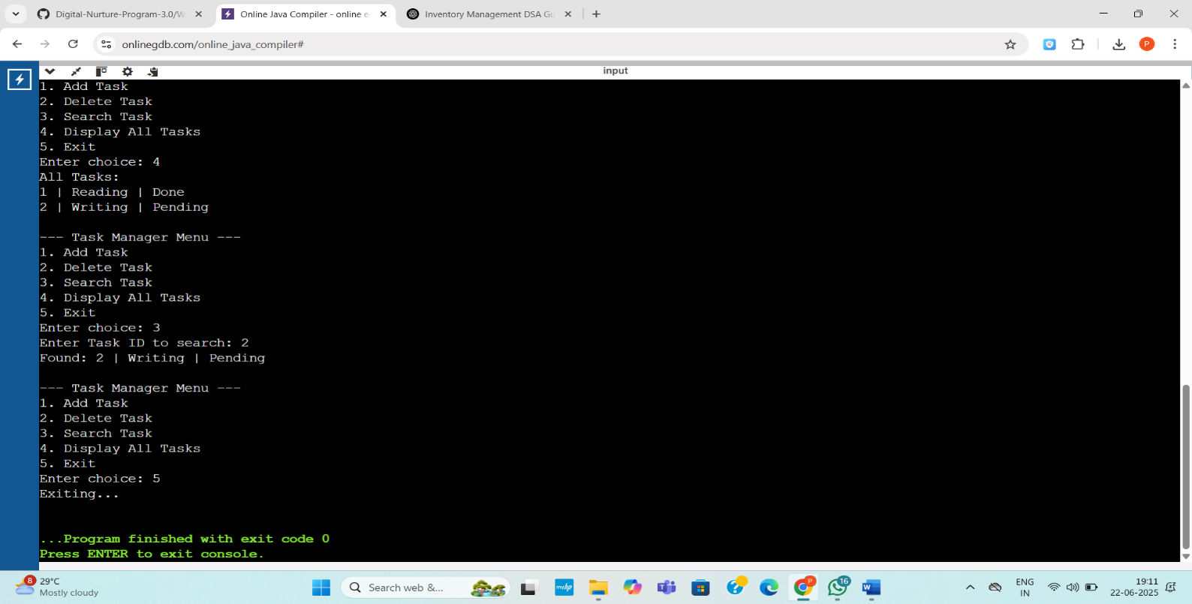

**Exercise 6: Library Management System**

**Code:**

import java.util.Arrays;

import java.util.Scanner;

public class LibraryManagement {

static class Book {

int bookId;

String title;

String author;

Book(int id, String title, String author) {

this.bookId = id;

this.title = title;

this.author = author;

}

public String toString() {

return bookId + " | " + title + " | " + author;

}

}

static Book linearSearch(Book[] books, String title) {

for (Book b : books) {

if (b.title.equalsIgnoreCase(title)) return b;

}

return null;

}

static Book binarySearch(Book[] books, String title) {

int low = 0, high = books.length - 1;

while (low <= high) {

int mid = (low + high) / 2;

int cmp = books[mid].title.compareToIgnoreCase(title);

if (cmp == 0) return books[mid];

else if (cmp < 0) low = mid + 1;

else high = mid - 1;

}

return null;

}

public static void main(String[] args) {

Book[] books = {

new Book(101, "C Programming", "Dennis Ritchie"),

new Book(102, "Java Fundamentals", "James Gosling"),

new Book(103, "Python Crash Course", "Eric Matthes"),

new Book(104, "Clean Code", "Robert C. Martin"),

new Book(105, "Data Structures", "Narasimha Karumanchi")

};

Scanner sc = new Scanner(System.in);

System.out.print("Enter title to search (Linear Search): ");

String title1 = sc.nextLine();

Book found1 = linearSearch(books, title1);

if (found1 != null)

System.out.println("Found: " + found1);

else

System.out.println("Book not found.");

Arrays.sort(books, (a, b) -> a.title.compareToIgnoreCase(b.title));

System.out.print("\nEnter title to search (Binary Search): ");

String title2 = sc.nextLine();

Book found2 = binarySearch(books, title2);

if (found2 != null)

System.out.println("Found: " + found2);

else

System.out.println("Book not found.");

sc.close();

}

}

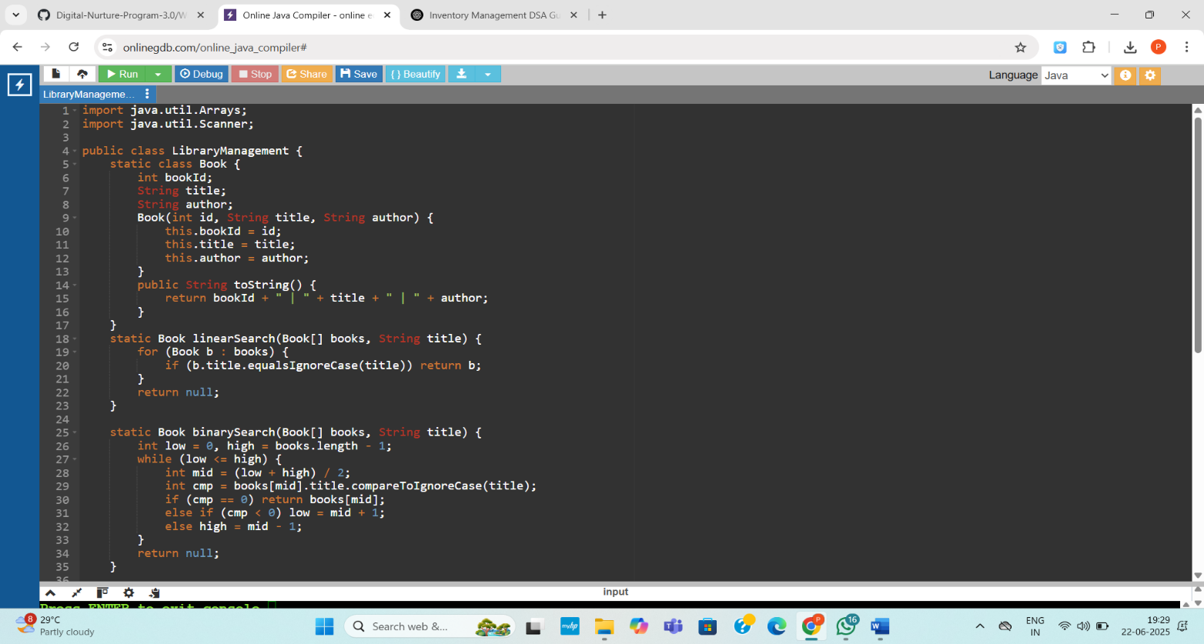

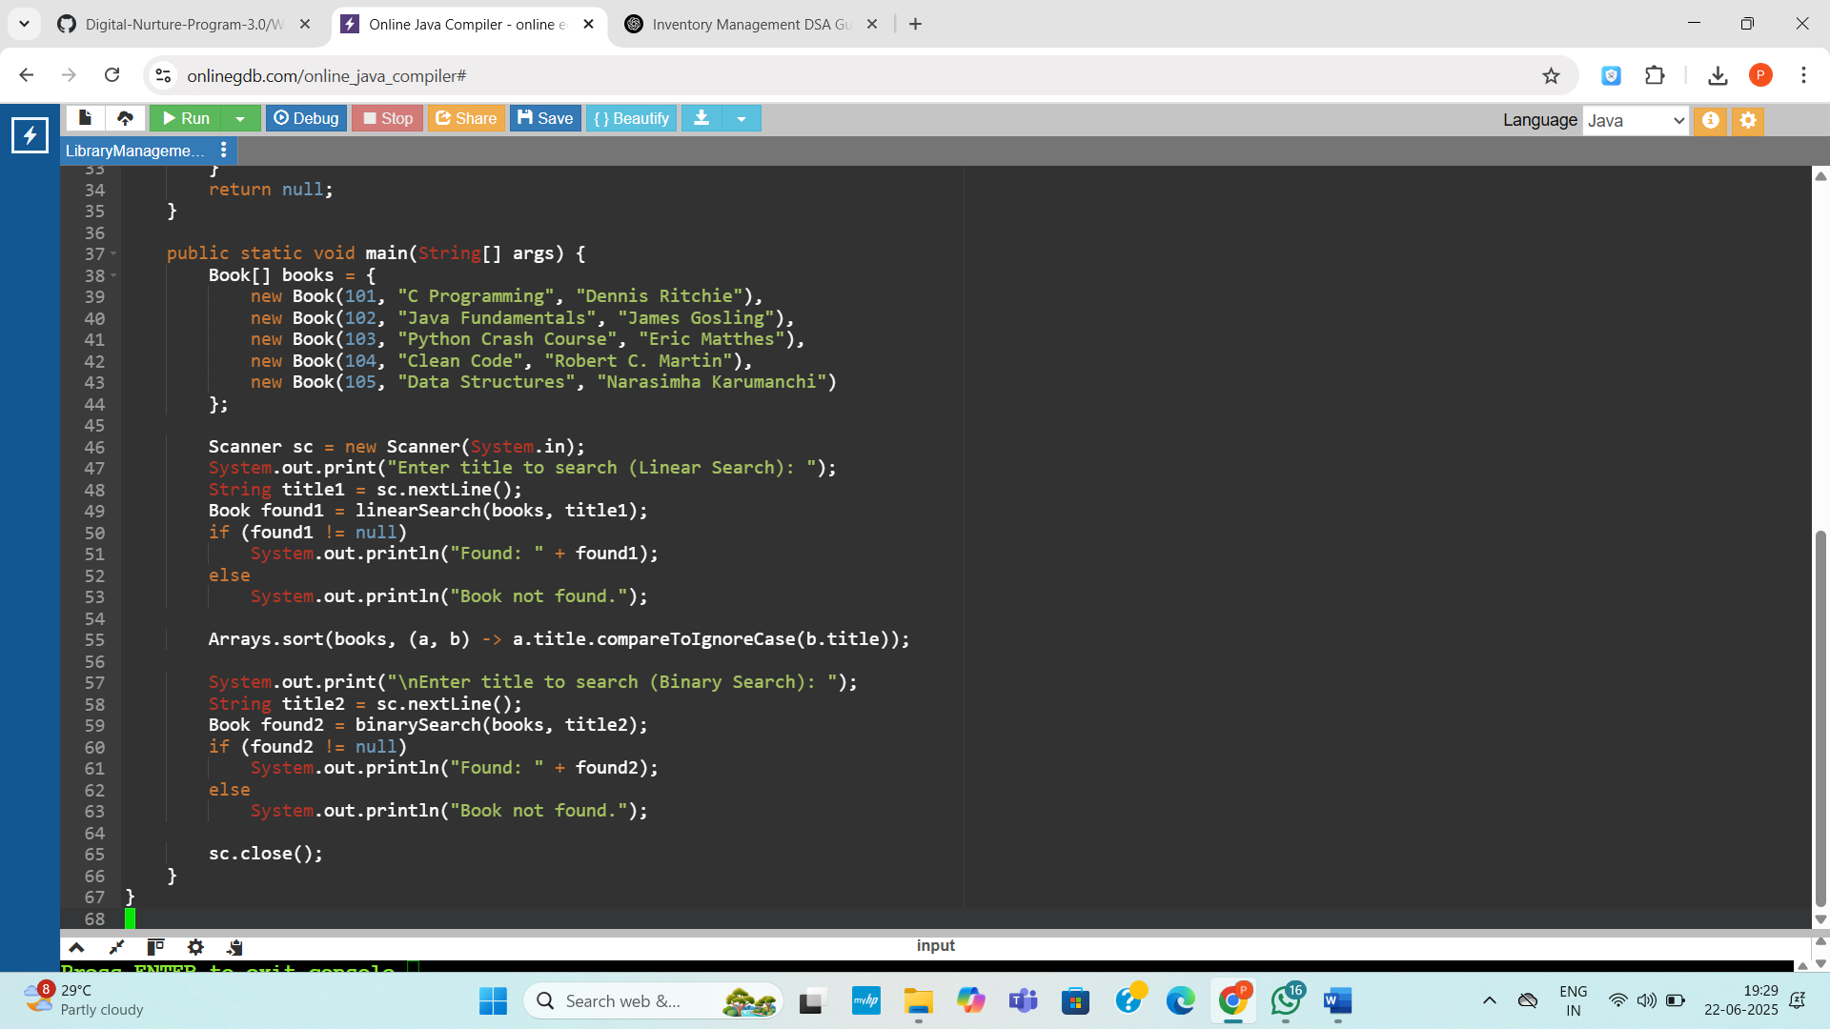

**Output:**

